**AUTONOMOUS TRASH/GARBAGE COLLECTOR ROBOT**

**by**

**SAYED MD TOWAHA**

**ID: 192-15-13126**

This Report Presented in Partial Fulfillment of the Requirements for the Degree of Bachelor of Science in Computer Science and Engineering.

Supervised By

**Fahad Faisal**

Assistant Professor

Department of CSE

Daffodil International University



**DAFFODIL INTERNATIONAL UNIVERSITY**

**Dhaka, Bangladesh**

**July 2023**

**APPROVAL**

This Project titled **“Autonomous Trash/Garbage Collector Robot”**, submitted by **Sayed MD Towaha** ID: **192-15-13126** to the Department of Computer Science and Engineering, Daffodil International University, has been accepted as satisfactory for the partial fulfillment of the requirements for the degree of B.Sc. in Computer Science and Engineering and approved as to its style and contents. The presentation has been held on **29 July, 2023**.

**Board of Examiners**

**(Name)** **Chairman**

**Designation**

Department of CSE

Faculty of Science & Information Technology

Daffodil International University

**(Name) Internal Examiner**

**Designation**

Department of CSE

Faculty of Science & Information Technology

Daffodil International University

**(Name) External Examiner**

**Designation**

Department of -------

Jahangirnagar University

**Declaration**

We hereby declare that, this project has been done by us under the supervision of **Fahad Faisal, Assistant Professor**, **Department of CSE** Daffodil International University. We also declare that neither this project nor any part of this project has been submitted elsewhere for award of any degree or diploma.

**Supervised by:**

**Fahad Faisal**

Assistant Professor

Department of CSE

Daffodil International University

**Submitted by:**

**Sayed MD Towaha**

ID: 192-15-13126

Department of CSE

Daffodil International University

**ACKNOWLEDGEMENT**

First, I express my heartiest thanks and gratefulness to almighty God for His divine blessing makes me possible to complete the final year project successfully.

I really grateful and wish my profound our indebtedness to **Fahad Faisal, Assistant Professor,** Department of CSE Daffodil International University, Dhaka. Deep Knowledge & keen interest of our supervisor in the field of ‘Robotics’ to carry out this project. His endless patience, scholarly guidance, continual encouragement, constant and energetic supervision, constructive criticism, valuable advice, reading many inferior drafts and correcting them at all stage have made it possible to complete this project.

I would like to express my heartiest gratitude to **Dr. Touhid Bhuiyan**, Head**,** Department of CSE, for his kind help to finish my project and also to other faculty member and the staff of CSE department of Daffodil International University.

Finally, I must acknowledge with due respect the constant support and patients of my parents.

**Abstract**

This project presents the development of an autonomous robotic trash collection system aimed at addressing the challenges of efficient waste management. The system integrates advanced technologies, including YOLOv8 for object detection and GPS navigation for precise waypoint tracking, along with mechanical components such as linear actuators, grippers, and motor drivers. The primary objective is to create an automated solution for trash collection, where the robot autonomously navigates its environment, detects trash objects using YOLOv8, and utilizes mechanical components for efficient collection and disposal. A user-friendly web interface allows users to input desired destination waypoints, providing a convenient means of guiding the robot's navigation. The system undergoes comprehensive testing to evaluate object detection accuracy, path navigation efficiency, trash collection effectiveness, and system reliability. Results demonstrate successful implementation, showcasing the system's ability to accurately detect objects, navigate to desired waypoints, efficiently collect and dispose of trash, and maintain a high level of reliability. The autonomous robotic trash collection system represents a significant advancement in automating waste management processes, reducing manual labor, and improving overall efficiency.

|  |  |
| --- | --- |
| **TABLE OF CONTENTS**  **CONTENTS** | **PAGE** |
| Board of examiners | i |
| Declaration | ii |
| Acknowledgments | iii |
| Abstract | iv |
| List of Figures | xi-xii |
| List of Table | xiii |
| **CHAPTER** |  |
| **CHAPTER 1: INTRODUCTION** | **1-5** |
| * 1. Introduction | 1-2 |
| * 1. Motivation | 2 |
| 1.3 Objectives  1.3.1 Automation of Waste Collection  1.3.2. Optimization of Waste Collection Routes  1.3.3. Enhancement of Operational Efficiency  1.3.4. Reduction of Health and Safety Risks  1.3.5. Environmental Impact Reduction  1.3.6. Robust Sensing and Detection Capabilities  1.3.7. Scalability and Integration  1.3.8. Evaluation and Validation  1.4 Expected Outcomes  1.4.1 Fully Functional Trash Collection Robot  1.4.2 Enhanced Waste Collection Efficiency  1.4.3 Reduction in Manual Labor  1.4.4 Optimal Resource Utilization  1.4.5 Accurate Waste Detection and Classification  1.4.6 Seamless Integration with Existing Infrastructure  1.4.7 Evaluation and Validation of Performance | 2  2  3  3  3  3  3  3  4  4  4  4  4  4  4  5  5 |
| **CHAPTER 2: BACKGROUND RESEARCH** | **6-12** |
| 2.1 Terminologies  2.1.1 Object Detection  2.1.2 YOLOv8  2.1.3 GPS Navigation  2.1.4 Mechanical Design Considerations  2.1.5 Autonomous Robotic System  2.1.6 Environmental Adaptability | 6  6  6  6  7  7  7 |
| 2.2 Related Work | 7-8 |
| 2.3 Comparative Analysis | 8-9 |
| 2.4 Scope of the problem  2.4.1 Manual Labor Intensity  2.4.2 Safety Hazards  2.4.3 Inefficient Collection Routes  2.4.4 Limited Sorting and Segregation  2.4.5 Lack of Real-time Monitoring | 9-10  10  10  10  10  10 |
| 2.5 Challenges  2.5.1 Technological Complexity  2.5.2 Environment Adaptability  2.5.3 Safety Considerations  2.5.4 Data Accuracy and Integration  2.5.5 Scalability and Deployment  2.5.6 Cost-effectiveness | 11-12  11  11  11  11  12  12 |
| **CHAPTER 3: REQUIREMENT SPECIFICATION** | **13-24** |
| 3.1 Business Process Modeling  3.2 Requirement Collection and Analysis  3.2.1 ARDUINO  3.2.2 L298N Motor Driver  3.2.3 Ultrasonic distance sensor  3.2.4 Ublox NEO-M8N GPS  3.2.5 Compass Sensor  3.2.6 BTS 7960 motor driver  3.2.7 DC Gear Motor  3.2.8 LM2596 STEP DOWN DC-DC Buck Converter  3.2.9 Webcam  3.2.10 Limit Switch  3.2.11 Jumper Wire  3.2.12 ESP8266  3.2.13 Laptop  3.2.14 Software Requirements | 13  14-24  14-15  15  15-16  16-17  17-18  18  18-19  19-20  20-21  21  21-22  22-23  23-24  24 |
| 3.3 Design requirement | 24 |
| **CHAPTER 4:** **DESIGN SPECIFICATION**  4.1 Front-End Design  4.1.1 Font Design  4.1.2 Side Design  4.2 Back-End Design  4.2.1 Visible Setup  4.2.2 Circuit Diagram  4.2.3 Reel  4.2.4 Circuit Diagram  4.3 Block Diagram  4.4 Interaction Design and User Experience (UX) | **25-30**  25-26  25-26  26  27-29  27  27-28  28  29  29-30  30 |
| **CHAPTER 5: IMPLEMENTATION AND TESTING**  5.1 Implementation of mechanical arm  5.1.1 Implementation of the door opening and closing system  5.1.2 Trash Inserting Door  5.1.3 Trash Disposal Door  5.2 Implementation of Back-end  5.2.1 Implementation of GPS navigation system  5.2.2 Location Input Form web page  5.2.3 Data Transmission and Processing  5.2.4 Path Navigation and Robot Control  5.2.5 Implementation of Trash Detection and Collection  5.3 Testing Implementation  5.3.1 Component Testing  5.3.2 Integration Testing  5.3.3 Functional Testing  5.3.4 Performance Testing  5.3.5 Error Handling and Exception Testing  5.3.6 Usability and User Experience Testing  5.4 Test Results and Reports | **31-39**  30-33  32  32  32-33  33-38  33  33-34  34  34-35  35-38  38-39  38  38  38  38  39  39  39 |
| **CHAPTER 6: IMPACT ON SOCIETY, ENVIRONMENT, AND SUSTAINABILITY**  6.1 Impact on Society  6.1.1 Efficiency and Productivity  6.1.2 Environmental Sustainability  6.1.3 Improved Hygiene and Sanitation  6.1.4 Traffic Management  6.1.5 Safety and Risk Reduction  6.1.6 Economic Benefits  6.1.7 Technological Advancement  6.2 Impact on the Environment  6.2.1 Waste Reduction and Recycling  6.2.2 Litter Prevention  6.2.3 Pollution Reduction  6.2.4 Greenhouse Gas Emissions  6.2.5 Optimization of Waste Disposal  6.2.6 Preservation of Natural Resources  6.2.7 Awareness and Education  6.3 Ethical Aspects  6.3.1 Data Privacy and Security  6.3.2 Transparency and Accountability  6.3.3 Fair Resource Allocation  6.3.4 Environmental Impact  6.3.5 Workforce Consideration  6.3.6 Accessibility and Inclusivity  6.3.7 Ethical Decision-Making  6.4. Sustainability Plan  6.4.1 Renewable Energy Integration  6.4.2 Life Cycle Assessment  6.4.3 Materials and Resource Efficiency  6.4.4 Maintenance and Upgrades  6.4.5 Collaboration and Partnerships  6.4.6 Monitoring and Evaluation  6.4.7 Community Engagement  6.4.8 Continuous Improvement  **CHAPTER 7: CONCLUSION AND FUTURE SCOPE**  7.1 Discussion and Conclusion  7.1.1 Discussion  7.1.2 Enhanced Efficiency  7.1.3 Reduction in Environmental Impact  7.1.4 Data-Driven Decision-Making  7.1.5 Safety and Reliability  7.1.6 Community Acceptance  7.1.7 Conclusion  7.2 Scope of Further Development  7.2.1 Advanced Sensor Technologies  7.2.2 Artificial Intelligence and Machine Learning  7.2.3 Integration with Smart City Infrastructure  7.2.4 Autonomous Fleet Management  7.2.5 Integration with Internet of Things (IoT) Devices  7.2.6 Enhanced Human-Robot Interaction  7.2.7 Integration of Sustainability Measures  **REFERENCES** | **40-46**  40-41  40  40  40  40-41  41  41  41  41-43  42  42  42  42  42-43  43  43  43-45  43-44  44  44  44  44  44  45  45-46  45  45  45-46  46  46  46  46  46  **47-50**  47-48  47  47  47  47  47-48  48  48  48-50  49  49  49  49  49  50  50  **51-52** |

**LIST OF FIGURES**

|  |  |
| --- | --- |
| **FIGURES** | **PAGE NO** |
| Figure 3.1: Business Process Modeling | 13 |
| Figure 3.2: Arduino Mega and Arduino Uno | 14 |
| Figure 3.3: L298N Motor Driver | 15 |
| Figure 3.4: Ultrasonic distance sensor | 16 |
| Figure 3.5: Ublox NEO-M8N GPS | 17 |
| Figure 3.6: Compass Sensor (HMC5883L) | 18 |
| Figure 3.7: BTS 7960 motor driver | 18 |
| Figure 3.8: Dc gear motor | 19 |
| Figure 3.9: LM2596 Buck Converter | 20 |
| Figure 3.10: Webcam | 21 |
| Figure 3.11: Limit Switch | 21 |
| Figure 3.12: Jumper Wire | 22 |
| Figure 3.13: ESP8226 | 23 |
| Figure 3.14: Laptop | 24 |
| Figure 4.1: Front Design | 26 |
| Figure 4.2: Side Design | 26 |
| Figure 4.3: Connection of all component | 27 |
| Figure 4.4: Arm controlling motor | 28 |
| Figure 4.5: Reel | 28 |
| Figure 4.6: Circuit Diagram | 29 |
| Figure 4.7: Block Diagram | 30 |
| Figure 5.1: Mechanical arm | 32 |
| Figure 5.2: Door opening and closing system | 33 |
| Figure 5.3: Location input form | 34 |
| Figure 5.4: Haversine distance formula | 35 |
| Figure 5.5: Object detected above x in the middle of y | 36 |
| Figure 5.6: Object detected above x in right | 36 |
| Figure 5.7: Object detected above x in left | 37 |
| Figure 5.8: Object detected under x in the middle of y | 37 |
|  |  |

**LIST OF TABLES**

|  |  |
| --- | --- |
| **TABLES** | **PAGE NO** |
| Table 5.1: Test Results and Report 39 | |

**CHAPTER 1**

**INTRODUCTION**

**1.1 Introduction:**

Waste management is a critical challenge faced by communities worldwide, with increasing urbanization and population growth leading to escalating volumes of waste. Efficient and sustainable waste collection and disposal methods are essential to maintain cleanliness, protect public health, and preserve the environment. Traditional waste collection methods often rely on manual labor and can be time-consuming, labor-intensive, and prone to inefficiencies. Therefore, there is a growing need for innovative technologies to streamline the waste collection process.

This project report presents a trash collection robot's design, development, and evaluation—a cutting-edge solution to automate and optimize the waste collection process. The robot's primary objective is to efficiently collect and dispose of trash in a safe, systematic, and environmentally friendly manner. By incorporating robotics and intelligent sensing capabilities, the proposed robot offers the potential to revolutionize waste management practices.

The motivation behind this project stems from the desire to address the limitations of conventional waste collection methods and harness the benefits of automation and robotics. The trash collection robot aims to overcome challenges such as labor-intensive processes, inconsistencies in waste collection schedules, and the potential health and Personnel responsible for waste management face safety risks. By leveraging advanced technologies, this project seeks to develop a robust and reliable solution that enhances waste collection operations' efficiency, accuracy, and effectiveness.

This project conducted extensive research and analysis to identify the essential requirements and functionalities of an autonomous trash collection robot. Through a multidisciplinary approach encompassing mechanical engineering, electronics, programming, and sensing technologies, the project team endeavored to design and implement a robot capable of navigating various terrains, detecting and classifying trash, and safely collecting and storing waste.

The significance of this project lies in its potential to bring numerous benefits to waste management systems. The trash collection robot offers increased productivity, reduced labor costs, optimized waste collection routes, improved cleanliness, and reduced environmental impact. Additionally, it can enhance waste management personnel's safety and well-being by minimizing their exposure to hazardous waste and physically demanding tasks.

This project report outlines the methodology for designing and developing the trash collection robot. It provides insights into mechanical design, sensing, and perception system, control and programming logic, and implementation. The report also presents the results of extensive testing and evaluation, highlighting the developed robot's performance, efficiency, and effectiveness. This project report is intended to serve as a comprehensive reference and contribute to the existing knowledge on waste management robotics.

This project endeavors to contribute to advancing waste management practices by proposing and implementing a trash collection robot. This innovative solution aims to optimize waste collection processes, improve operational efficiency, and promote a cleaner and healthier environment by harnessing the potential of robotics and intelligent sensing. The subsequent sections of this report will delve into the project's methodology, implementation details, results, and recommendations for future enhancements.

**1.2 Motivation:**

This project stems from the need to address the limitations of traditional waste collection methods and embrace innovative solutions for efficient and sustainable waste management. By developing a trash collection robot, we aim to automate and optimize waste collection processes, minimize manual labor, enhance operational efficiency, reduce health risks for waste management personnel, and promote a cleaner and healthier environment. By integrating robotics, intelligent sensing, and autonomous navigation, this project seeks to revolutionize waste management practices and contribute to a more efficient and sustainable future.

**1.3 Objectives:**

The primary objective of this project is to design, develop, and evaluate a trash collection robot that enhances waste management practices' efficiency, effectiveness, and sustainability. Through the integration of robotics, intelligent sensing, and autonomous navigation, the project aims to achieve the following objectives:

**1.3.1 Automation of Waste Collection:**

Develop a robot autonomously navigates and collects trash from designated areas. The robot should efficiently detect, classify, and collect different types of waste, streamlining the waste collection process, and reducing the reliance on manual labor.

**1.3.2 Optimization of Waste Collection Routes:**

Implement intelligent route planning algorithms to optimize the robot's collection routes. By considering factors such as location, waste volume, and real-time data, the objective is to minimize travel time and maximize the volume of waste collected within a given time frame.

**1.3.3. Enhancement of Operational Efficiency:**

Improve waste collection systems' productivity and operational efficiency by deploying the trash collection robot. The objective is to streamline the collection processes, reduce delays, and ensure timely waste removal, leading to cleaner surroundings and more effective waste management practices.

**1.3.4 Reduction of Health and Safety Risks:**

Mitigate the safety risks associated with manual waste collection by deploying the robot.

The objective is to relieve human workers from physically demanding tasks and potential exposure to hazardous waste materials, promoting their safety and well-being in waste management operations.

**1.3.5 Environmental Impact Reduction:**

Minimize the environmental footprint of waste collection operations by optimizing the robot's navigation and waste collection mechanisms. The objective is to reduce unnecessary vehicle travel, traffic congestion, and carbon emissions promoting sustainable waste management practices and environmental stewardship.

**1.3.6. Robust Sensing and Detection Capabilities:**

Incorporate advanced sensing technologies to enable accurate detection, classification, and handling of different types of waste. The objective is to develop a reliable sensing system to distinguish between various waste materials and operate effectively in diverse environmental conditions.

**1.3.7 Scalability and Integration:**

Design the trash collection robot with scalability and integration, allowing for potential deployment in different waste management systems. The objective is to ensure compatibility and interoperability with existing waste management infrastructure, enabling seamless robot integration into real-world operations.

**1.3.8. Evaluation and Validation:**

Evaluate the performance and effectiveness of the trash collection robot, the objective is to assess its navigation capabilities, waste detection and collection efficiency, operational reliability, and overall contribution to waste management practices.

**1.4 Expected Outcomes:**

This project aims to achieve several anticipated outcomes that will contribute to the advancement of waste management practices and the field of robotics. The following outcomes are expected:

**1.4.1 Fully Functional Trash Collection Robot:**

The primary expected outcome is the development of a fully functional trash collection robot. The robot can autonomously navigate various terrains, detect and classify different types of waste, and efficiently collect and store trash. It will be a tangible demonstration of integrating robotics, intelligent sensing, and autonomous navigation for waste management.

**1.4.2 Enhanced Waste Collection Efficiency:**

The project expects to improve efficiency by deploying the trash collection robot. By optimizing collection routes, reducing travel time, and automating waste detection and collection processes, the robot is anticipated to streamline waste management operations and enhance overall efficiency.

**1.4.3 Reduction in Manual Labor:**

The project endeavors to significantly reduce the reliance on manual labor in waste collection activities. Deploying the trash collection robot will relieve human workers from physically demanding and potentially hazardous tasks, improving their safety and well-being. This outcome aligns with the project's goal of minimizing waste management operations' health and safety risks.

**1.4.4 Optimal Resource Utilization:**

The project expects to achieve optimal resource utilization with intelligent route planning algorithms. The trash collection robot will minimize unnecessary vehicle travel, reduce fuel consumption, and contribute to lower carbon emissions. This outcome aligns with the project's objective of promoting sustainable waste management practices and environmental stewardship.

**1.4.5 Accurate Waste Detection and Classification:**

The project anticipates the development of a robust sensing and perception system for accurate waste detection and classification. The trash collection robot will be capable of distinguishing different types of waste, enabling targeted collection and appropriate disposal. This outcome is crucial for efficient waste management and recycling efforts.

**1.4.6 Seamless Integration with Existing Infrastructure:**

The project aims to design the trash collection robot with compatibility and integration in mind. The expected outcome is a robot seamlessly integrating with existing waste management infrastructure, such as waste collection vehicles and disposal systems. This outcome will facilitate the adoption and deployment of the robot in real-world waste management operations.

**1.4.7 Evaluation and Validation of Performance:**

The project expects to conduct comprehensive testing and evaluation of the trash collection robot's performance. The robot will undergo rigorous assessments to measure its navigation accuracy, waste detection, collection efficiency, reliability, and overall contribution to waste management practices. This outcome will provide valuable insights for further improvements and future research in the field.

**CHAPTER 2**

**BACKGROUND RESEARCH**

**2.1 Terminologies:**

This section aims to provide a comprehensive understanding of the key terminologies and concepts used throughout the project report. By establishing clear definitions and explanations, readers can grasp the technical nuances of the autonomous robotic trash collection system. It is essential to note that the following definitions are based on commonly accepted industry standards and established literature.

**2.1.1 Object Detection:**

Object detection refers to the computer vision task of identifying and localizing specific objects within an image or video frame. In the context of this project, object detection is the process by which the robotic system recognizes and discerns trash objects from the surrounding environment. The system utilizes advanced algorithms and techniques to accurately identify and locate trash items, facilitating their subsequent collection and disposal.

**2.1.2 YOLOv8:**

YOLOv8, an abbreviation for "You Only Look Once version 8," is an object detection algorithm renowned for its real-time and high-accuracy performance. It operates by dividing an input image into a grid and predicting bounding boxes and class probabilities for objects within each grid cell. YOLOv8 offers exceptional speed and accuracy, making it a popular choice for real-world applications, including robotic trash collection.

**2.1.3 GPS Navigation:**

GPS, or Global Positioning System, is a satellite-based navigation system widely used for precise positioning and navigation purposes. It utilizes a network of satellites to provide location information, enabling accurate localization and navigation in outdoor environments. In the context of this project, GPS navigation is integral to the autonomous movement of the robotic system. By leveraging GPS data, the system can determine its position, plan optimal paths, and navigate towards designated trash objects and dumping locations.

**2.1.4 Mechanical Design Considerations:**

Mechanical design considerations refer to the principles and factors involved in the construction and configuration of the physical structure of the robotic system. In the context of this project, mechanical design considerations encompass aspects such as the selection of materials, the construction of a robust chassis, the incorporation of a reliable trash collection mechanism, and the integration of sensors for obstacle detection. The mechanical design aims to ensure the system's durability, stability, and adaptability to real-world environments.

**2.1.5 Autonomous Robotic System:**

An autonomous robotic system refers to a self-operating machine or device that can perform tasks and make decisions without direct human intervention. In the context of this project, an autonomous robotic system is designed to autonomously identify, collect, and deposit trash objects in a designated location. It incorporates various technologies, such as object detection algorithms and GPS navigation, to enable independent decision-making and efficient operation.

**2.1.6 Environmental Adaptability:**

Environmental adaptability refers to the capability of the robotic system to function effectively and reliably in diverse and dynamic environments. In the context of this project, the robotic system should be able to operate in various outdoor settings, such as parks, streets, or public spaces, where trash objects may be scattered and the terrain may vary. The system should exhibit adaptability to handle different types and sizes of trash objects and navigate through obstacles encountered in its surroundings.

**2.2 Related Work**

This section presents an overview of the existing research and developments related to trash collection robots. The following studies and projects highlight the advancements in the field and provide valuable insights for our project:

Autonomous Trash Collector Robot with Wireless Charging System in a Campus Environment (2019) by Analene Nagayo et al [1]. This paper presents the design and implementation of an autonomous trash collector robot that can operate in a campus environment. The robot is equipped with a wireless charging system, which allows it to be recharged without human intervention. Development of Water Surface Mobile Garbage Collector Robot (2022) by Muhammad Naqib et al [2]. This paper presents the development of a water surface mobile garbage collector robot. The robot is designed to collect garbage from small-scale lakes, narrow rivers, and drains. The robot is controlled using a smartphone application, and it is equipped with a proximity sensor and image processing techniques to detect garbage on the water surface. Akib et al. presents the design of a cost-effective remote-controlled floating waste removing robot that can be used in canals, ponds, rivers, or oceans [3]. The robot is built with two propellers connected to two DC motors for movement, a mobile application-based Bluetooth control system, and a robotic hand for easy trash collection. A conveyor belt arrangement guides the trash to the collection box, and a sensor arrangement protects against overloading. The prototype can collect trash weighing up to 10 kg and clean an area of about 3000 square centimeters while drawing only 45 watts from the battery. The robot can work for four hours continuously without needing to be charged. Another paper that might be of interest is “Aquatic Iguana: A Floating Waste Collecting Robot with IoT Based Water Monitoring System” published in the 2020 7th International Conference on Electrical Engineering, Computer Sciences and Informatics (EECSI) [4]. This paper presents an affordable and advanced floating garbage removing robot called “Aquatic Iguana” that moves around the surface of the water and collects floating waste material such as plastic, packets, leaves, etc. Along with the waste-collecting system, the robot also includes water monitoring with pH, turbidity, temperature sensors, and a live streaming feature [4]. Jha et al. in 2019 addresses the problem of garbage collection and dumping in India and proposes a solution in the form of an autonomous garbage collecting robot that works with an Arduino controller. The robot is built on an aluminum base of size 30 × 40 cm and is powered by a 12 V, 7.5 A battery. The robot’s movement is controlled by motors connected to the programmed Arduino, and it can only move on hard, cemented surfaces. When it senses an obstruction, it follows the code and proceeds to lift the garbage as per the designed mechanism [5]. These related works demonstrate the ongoing efforts to develop intelligent trash collection robots with enhanced waste identification, sorting, navigation, and energy efficiency capabilities. Our project builds upon these advancements, aiming to contribute further to the field by addressing specific challenges and incorporating novel features into our trash collection robot.

**2.3 Comparative Analysis**

In order to make informed decisions regarding the technologies and approaches employed in the development of an autonomous robotic trash collection system, a comparative analysis is conducted. This analysis aims to evaluate and compare different object detection algorithms, navigation systems, and other relevant factors to determine the most suitable options for the project. The following subsections provide an in-depth examination of these comparative aspects. The selection of an appropriate object detection algorithm is crucial for the accurate identification and localization of trash objects within the robotic system's environment. In the comparative analysis, various algorithms, including YOLOv8, are evaluated based on factors such as detection accuracy, speed, and ability to handle real-time processing. The analysis examines the strengths and weaknesses of each algorithm, considering their performance in complex and cluttered scenes, their robustness to varying lighting conditions, and their ability to handle different types and sizes of trash objects. By comparing these algorithms, the analysis aims to determine the most suitable algorithm for achieving reliable object detection in the context of the robotic trash collection system. Navigation plays a vital role in ensuring that the robotic system can autonomously maneuver and reach designated trash objects and dumping locations. The comparative analysis assesses different navigation systems, such as GPS, LiDAR (Light Detection and Ranging), and SLAM (Simultaneous Localization and Mapping). Factors considered include accuracy, reliability, robustness to environmental conditions (e.g., outdoor settings), and suitability for real-time operation. The analysis also examines the integration complexity and cost implications associated with each navigation system. By comparing these systems, the analysis aims to identify the most suitable navigation solution to enable precise and efficient movement of the robotic system.The comparative analysis extends beyond object detection algorithms and navigation systems to consider other relevant factors that impact the performance and usability of the robotic trash collection system. These factors may include power consumption, computational resources required, scalability, and ease of maintenance. By comparing these additional factors, the analysis aims to identify potential trade-offs and challenges associated with the different options. This comprehensive assessment helps in making informed decisions regarding the overall system architecture and technology stack.

**2.4 Scope of the problem**

The scope of the problem addressed in this project is the inefficiencies and limitations associated with traditional methods of trash collection. The project aims to develop a trash collection robot to overcome these challenges and improve waste management processes. The specific aspects within the scope of the problem include:

**2.4.1 Manual Labor Intensity:**

Traditional trash collection methods rely heavily on manual labor, which can be physically demanding and time-consuming. The project seeks to reduce the labor-intensive nature of waste collection by automating the process using a robot.

**2.4.2 Safety Hazards:**

Trash collectors are exposed to various safety hazards, including sharp objects, hazardous materials, and unpredictable waste conditions. The project aims to mitigate these risks by introducing a robot that can perform waste collection tasks in hazardous or challenging environments, thus ensuring the safety of human workers.

**2.4.3 Inefficient Collection Routes:**

Manual waste collection often follows predetermined routes that may need to be optimized for efficiency. The project intends to address this issue by developing a robot capable of autonomously navigating various environments and optimizing collection routes based on proximity, waste accumulation, and real-time monitoring data.

**2.4.4 Limited Sorting and Segregation:**

Traditional waste collection systems may lack proper waste sorting and segregation mechanisms, leading to suboptimal recycling and resource recovery. The project aims to incorporate intelligent algorithms and sensors into the robot to enable effective waste sorting and segregation, thereby promoting recycling efforts and reducing waste sent to landfills.

**2.4.5 Lack of Real-time Monitoring:**

Manual waste collection methods often need more real-time monitoring capabilities, making it challenging to optimize collection routes, allocate resources efficiently, and respond promptly to changing waste management needs. The project aims to address this by equipping the robot with sensors and data communication systems to enable real-time monitoring of waste bins, collection points, and other relevant parameters.

**2.5 Challenges**

The development and implementation of a trash collection robot pose several challenges that need to be addressed for the successful execution of the project. These challenges include:

**2.5.1 Technological Complexity:**

Designing and building a sophisticated trash collection robot involves integrating various technologies such as robotics, computer vision, machine learning, and autonomous navigation. The complexity of combining these technologies and ensuring their seamless operation poses a significant challenge. It requires a deep understanding of the underlying principles and expertise in integrating different hardware and software components.

**2.5.2 Environment Adaptability:**

Trash collection environments can be diverse and unpredictable. The robot must be capable of adapting to different terrains, weather conditions, and waste types. Navigating through cluttered or uneven surfaces, identifying and handling different types of waste materials, and operating in varying light conditions are some challenges associated with environmental Adaptability. Developing robust algorithms and sensor systems to address these challenges is crucial.

**2.5.3 Safety Considerations:**

Ensuring the safety of the robot and humans in the vicinity is paramount. Trash collection sites may contain hazardous materials, sharp objects, or potentially harmful substances. The robot should have safety mechanisms to prevent accidents, such as collision avoidance systems and emergency stop features. Adhering to safety standards and regulations throughout the design and implementation phases is essential.

**2.5.4 Data Accuracy and Integration:**

For efficient waste management, the robot needs to accurately identify, sort, and collect different types of waste. This requires robust computer vision algorithms and reliable data integration techniques. Challenges may arise in handling variations in waste appearance, dealing with occlusions or partially filled bins, and achieving high accuracy in waste classification. Developing and training machine learning models on diverse and representative datasets is critical to overcoming these challenges.

**2.5.5 Scalability and Deployment:**

To make a meaningful difference., the trash collection robot should be scalable and deployable in various settings, such as residential areas, commercial spaces, or public spaces. Ensuring the robot's Adaptability to different waste collection scenarios and the ability to handle varying volumes of waste is a challenge. Considerations must be given to factors such as power management, maintenance, and scalability of the system as it expands to accommodate more extensive waste management operations.

**2.5.6 Cost-effectiveness:**

Developing a trash collection robot that is cost-effective and economically viable is crucial for its widespread adoption. Balancing the costs associated with research and development, hardware components, sensors, and maintenance against the robot's efficiency gains and long-term benefits is a challenge. Identifying cost-effective solutions, exploring partnerships, and considering the potential for future scalability and cost reduction are key factors to address this challenge.

By recognizing and addressing these challenges, the project can overcome technical, operational, and economic hurdles, leading to the successful development and implementation of an efficient and effective trash-collection robot.

**CHAPTER 3**

**REQUIREMENT SPECIFICATION**

**3.1 Business Process Modeling:**

The business process model delineates the sequential flow of activities, beginning with initial planning and requirements gathering, followed by system design, component selection, and integration. It encompasses critical aspects such as the implementation of object detection algorithms and navigation systems, as well as mechanical design considerations. The model emphasizes the iterative nature of the development process, wherein testing and feedback drive continuous improvement. Interactions and dependencies between different activities and components are elucidated in the model, facilitating effective collaboration and communication. It underscores the significance of integrating object detection algorithms with the perception module and integrating GPS navigation with the movement control module. The model emphasizes the iterative feedback loop between stakeholders, enabling constant refinement and enhancement of the system.

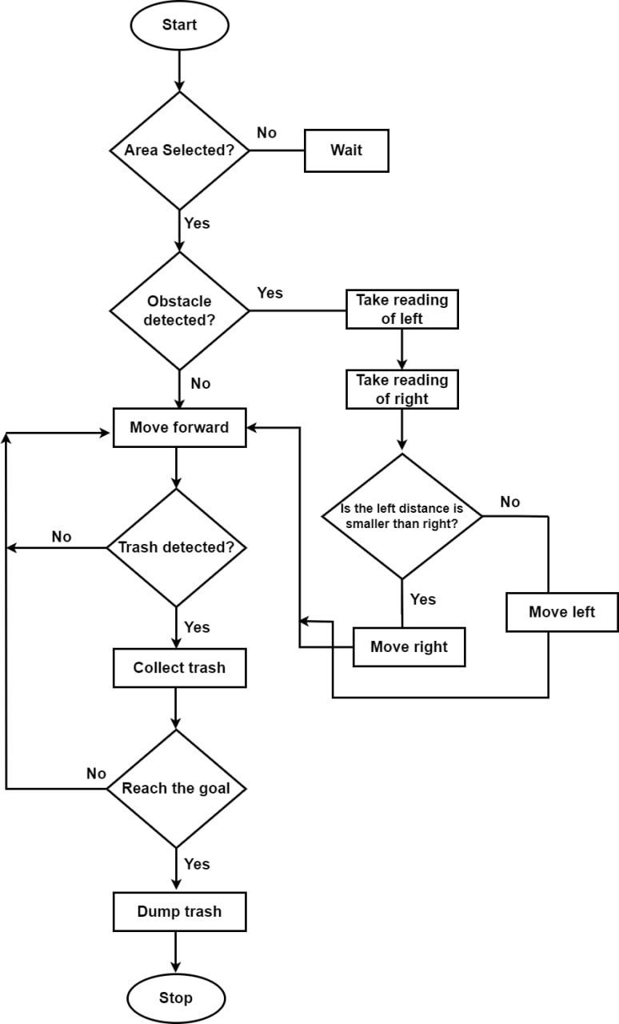

Figure 3.1: Business Process Modeling

**3.2 Requirement Collection and Analysis**

**3.2.1 ARDUINO**

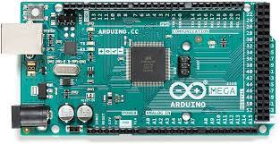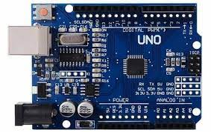

Figure 3.2: Arduino Mega and [Arduino Uno](https://encrypted-tbn0.gstatic.com/images?q=tbn:ANd9GcQeQ0I97BbYLN-91o1TBJh8DU9M6_OGcylCWA&usqp=CAU) [19]

Arduino is a popular open-source electronics platform that provides a flexible and user-friendly environment for creating interactive projects. It consists of both hardware and software components, making it a versatile tool for prototyping and developing various electronic systems. In the context of the autonomous robotic trash collection project, Arduino plays a crucial role in controlling and coordinating the robot's movements and actions.

The main use of Arduino in this project is to serve as the central microcontroller that interfaces with the different sensors, actuators, and modules of the robotic system. Arduino boards are equipped with input/output pins, analog-to-digital converters, and communication interfaces, making them ideal for integrating and controlling various electronic components. By leveraging the capabilities of Arduino, the project can achieve precise control and automation of the robot's functions. One of the key advantages of using Arduino in this project is its ease of use and accessibility. Arduino offers a simple and intuitive programming language, which allows even those with limited coding experience to develop and modify the system's functionalities. The Arduino software, also known as the Integrated Development Environment (IDE), provides a user-friendly interface for writing and uploading code to the Arduino board. Arduino boards are available in different models and sizes, allowing flexibility in choosing the most suitable board for the project's requirements. The boards are relatively affordable, making them a cost-effective choice for prototyping and small-scale productions. Additionally, Arduino has a large and active community of users, providing access to a vast array of resources, tutorials, and libraries that can expedite the development process. In the autonomous robotic trash collection system, Arduino can be utilized to interface with sensors such as ultrasonic or infrared sensors to detect obstacles and measure distances. It can also interface with motor drivers to control the movement of wheels or other locomotion mechanisms. Additionally, Arduino can be employed to communicate with other components of the system, such as the object detection algorithms or the GPS navigation system.

Overall, Arduino serves as the brains of the autonomous robotic trash collection system, facilitating the integration and coordination of various components. It empowers the project with the ability to sense the environment, make intelligent decisions, and execute precise actions. By leveraging the simplicity, versatility, and accessibility of Arduino, the project can achieve a reliable and efficient robotic system that effectively collects and dumps trash.

**3.2.2 L298N Motor Driver**

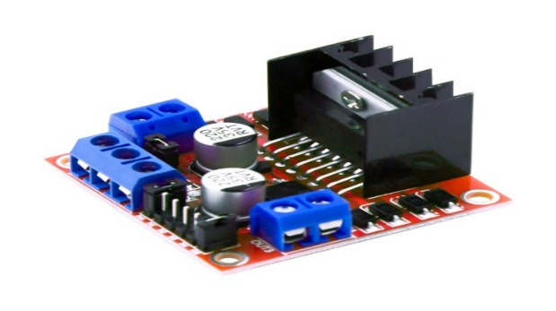

Figure 3.3: [L298N Motor Driver](https://encrypted-tbn0.gstatic.com/images?q=tbn:ANd9GcQ6AIBSF5KZ9Z_2Qpvi-ZtJbWOahj33zKtkfQ&usqp=CAU) [20]

The L298N Motor Driver is a motor controller module widely used in robotics and automation. It allows precise control over the speed and direction of DC motors. In the autonomous robotic trash collection project, the L298N Motor Driver is utilized to control the motors responsible for the robot's movement. It interfaces with Arduino to regulate motor speed and direction, enabling efficient navigation, obstacle avoidance, and successful trash collection tasks. The L298N Motor Driver offers high-current and voltage handling capabilities, making it suitable for powering motors with significant power requirements. It ensures reliable and controlled movement of the robot while incorporating protective features for motor safety.

**3.2.3 Ultrasonic distance sensor**

The ultrasonic distance sensor is a crucial component utilized in the autonomous robotic trash collection project. This sensor uses ultrasonic waves to measure the distance between the robot and nearby objects or obstacles. Its primary purpose is to enable the robot to detect and avoid obstacles during its navigation process.

By emitting ultrasonic waves and measuring the time it takes for the waves to bounce back after hitting an object, the sensor can accurately calculate the distance between the robot and the obstacle. This information is then utilized to adjust the robot's movement and ensure safe traversal in its environment.

The ultrasonic distance sensor plays a vital role in enhancing the robot's autonomy and navigation capabilities. It enables the robot to detect obstacles in real-time, allowing it to make informed decisions about its path and avoid potential collisions. This feature is crucial for ensuring the safety of the robot and the successful execution of the trash collection tasks. 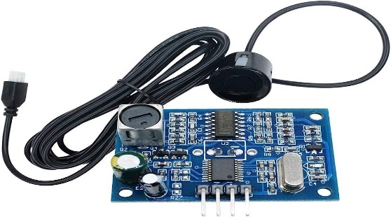

Figure 3.4: [Ultrasonic distance sensor](https://encrypted-tbn0.gstatic.com/images?q=tbn:ANd9GcS6al2SluWsWY-I-CR9RDF6XSCJQ1khFBY7PA&usqp=CAU) [21]

**3.2.4 Ublox NEO-M8N GPS**

The NEO-8 GPS module is an essential component utilized in the autonomous robotic trash collection project. This module is designed to receive signals from Global Navigation Satellite Systems (GNSS) such as GPS, GLONASS, Galileo, and BeiDou. Its primary purpose is to provide accurate and reliable positioning information to the robot. The NEO-8 GPS module receives signals from multiple satellites and uses trilateration techniques to determine the robot's precise location on Earth. It provides coordinates such as latitude, longitude, and altitude, along with other navigation data like speed and heading.

In the context of the project, the NEO-8 GPS module is integrated into the robot's control system, allowing the robot to accurately navigate its environment. By continuously receiving and processing GPS signals, the module enables the robot to determine its current position and plan optimal routes for trash collection.

The GPS data acquired from the NEO-8 module is utilized for various purposes in the project. Firstly, it helps the robot establish its initial position and serves as a reference point for navigation. As the robot moves, the GPS module updates its position in real-time, allowing the robot to track its movement and accurately reach predefined waypoints.

Additionally, the NEO-8 GPS module enables the robot to perform location-based tasks. For example, it can identify specific areas where trash needs to be collected based on GPS coordinates. By combining the GPS data with other sensors and mapping algorithms, the robot can autonomously navigate to these target locations, collect trash, and deposit it in the designated area.

The use of the NEO-8 GPS module enhances the autonomy and efficiency of the robotic trash collection system. It enables the robot to navigate accurately, plan optimal routes, and carry out trash collection tasks with precision. By leveraging the GPS data from the module, the project achieves effective localization, route optimization, and successful completion of trash collection operations.

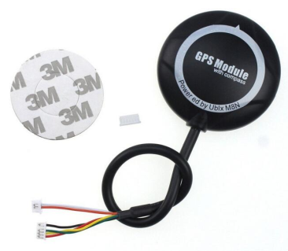

Figure 3.5: [Ublox NEO-M8N GPS](https://encrypted-tbn0.gstatic.com/images?q=tbn:ANd9GcTq9IFo7eFaw6dkUSy8VdDW6qSYE9aZ1xUdLqjtPvbdDnTl0m5bpWnWMonK2VaA13nPPho&usqp=CAU) [22]

**3.2.5 Compass Sensor**

The Compass Sensor, also known as a magnetic field sensor, is a vital component in the autonomous robotic trash collection project. It detects the Earth's magnetic field to determine the robot's orientation and heading. This sensor enables the robot to maintain a consistent direction while navigating and ensures accurate movement towards predefined targets. By integrating the Compass Sensor into the project, the robot can effectively adapt to various terrains, avoid obstacles, and perform precise trash collection operations. It enhances the robot's navigation capabilities and contributes to the overall success and efficiency of the project.

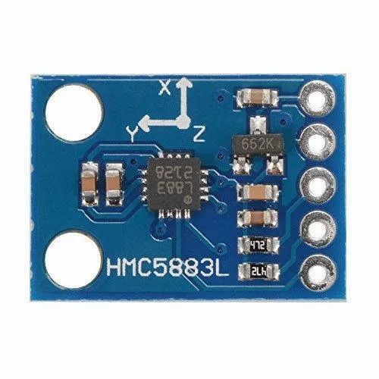

Figure 3.6: Compass Sensor ([HMC5883L](https://encrypted-tbn0.gstatic.com/images?q=tbn:ANd9GcQa_vM_BVqRXvMgydZ0Pewut11ET1PFpSQGmg&usqp=CAU)) [23]

**3.2.6 BTS 7960 motor driver**

The BTS7960 Motor Driver is a key component used in the autonomous robotic trash collection project. It is responsible for controlling the DC motors that drive the robot's movement. The motor driver module enables precise speed and direction control, allowing the robot to navigate various terrains and perform trash collection tasks accurately. It provides high current handling capabilities and incorporates protective features for motor and driver safety. The BTS7960 Motor Driver ensures efficient motor control and enhances the overall functionality of the robotic system.

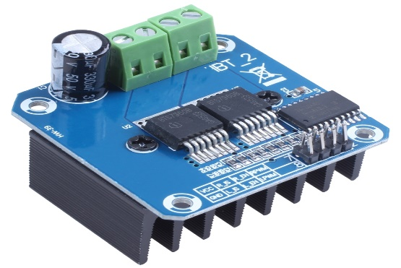

Figure 3.7: [BTS 7960 motor driver](https://encrypted-tbn0.gstatic.com/images?q=tbn:ANd9GcQkor2879LHkBbn3cSOllPBJzIwma0gEROwvA&usqp=CAU) [24]

**3.2.7 DC Gear Motor**

The DC gear motor is a crucial component used in the autonomous robotic trash collection project. It consists of a DC motor combined with a gearbox, resulting in increased torque and reduced rotational speed. This combination makes it ideal for applications requiring high torque and precise control.

In this project, the DC gear motor is utilized to drive various mechanical components of the robot, such as wheels or arms. The motor's high torque output allows the robot to move effectively and handle the weight of the trash it collects. The gearbox provides the necessary speed reduction, enabling the robot to achieve precise movements and perform intricate tasks.

The DC gear motor offers several advantages for the project. Its compact size and robust construction make it suitable for use in constrained spaces and rugged environments. It provides reliable and efficient power transmission, ensuring the robot's smooth and consistent operation.

Furthermore, the DC gear motor is compatible with the motor driver module, such as the BTS7960 Motor Driver, which facilitates accurate control of its speed and direction. This integration allows the robot's control system, such as an Arduino microcontroller, to regulate the motor's performance and adapt it to different scenarios encountered during trash collection.

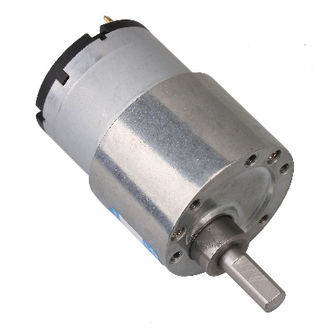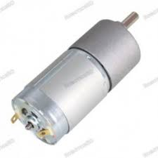

Figure 3.8: [Dc gear motor](https://udvabony.com/wp-content/uploads/2019/05/Metal-37GB-Gear-Box-Dc-12v-Motor-1-1.jpeg) [25]

**3.2.8 LM2596 STEP DOWN DC-DC Buck Converter**

The LM2596 Step-Down DC-DC Buck Converter is a crucial component in the autonomous robotic trash collection project. It efficiently converts a higher DC voltage to a lower, more stable voltage required by the robot's electronic components. The converter ensures consistent power supply, maximizes battery life, and provides voltage regulation and noise filtering. Its compact size and compatibility with different power sources make it versatile and adaptable to the project's needs. Overall, the LM2596 Buck Converter enhances the reliability, power efficiency, and performance of the robotic system.

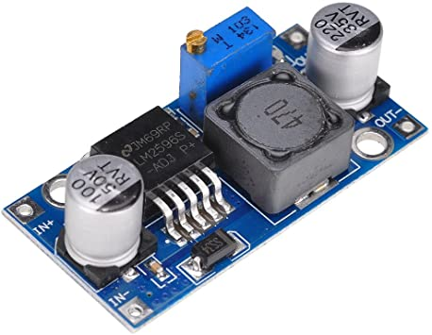

Figure 3.9: [LM2596 Buck Converter](https://store.roboticsbd.com/4477-large_default/lm2596-dc-dc-step-down-adjustable-power-supply-module-3a-max-buck-converter-robotics-bangladesh.jpg) [26]

**3.2.9 Webcam**

The webcam is an essential component used in the autonomous robotic trash collection project. It is a digital camera that captures live video and feeds it to the robot's control system for processing and analysis.

In this project, the webcam serves multiple purposes. Firstly, it provides visual perception to the robot, allowing it to "see" its surroundings and detect objects, including trash, in real-time. The camera captures video footage of the environment, which is then processed using computer vision algorithms to identify and locate trash items.

The webcam's video feed is utilized for object detection and recognition tasks. Advanced image processing techniques, such as the YOLOv8 algorithm, can be applied to analyze the video frames and identify the presence of trash objects with high accuracy. Furthermore, the webcam enables the robot to navigate and localize itself within the environment. By capturing images of landmarks or reference points, the robot can determine its position and orientation relative to its surroundings. The use of the webcam in this project enhances the robot's perception and decision-making capabilities. It allows the robot to autonomously detect and locate trash, enabling efficient and targeted collection. The visual information captured by the webcam is combined with other sensory inputs, such as GPS and distance sensors, to create a comprehensive perception system for the robot. Overall, the webcam plays a crucial role in the autonomous robotic trash collection project. It provides visual perception to the robot, allowing it to detect and locate trash objects accurately. The integration of the webcam enhances the robot's ability to navigate, localize itself, and execute targeted trash collection operations effectively.

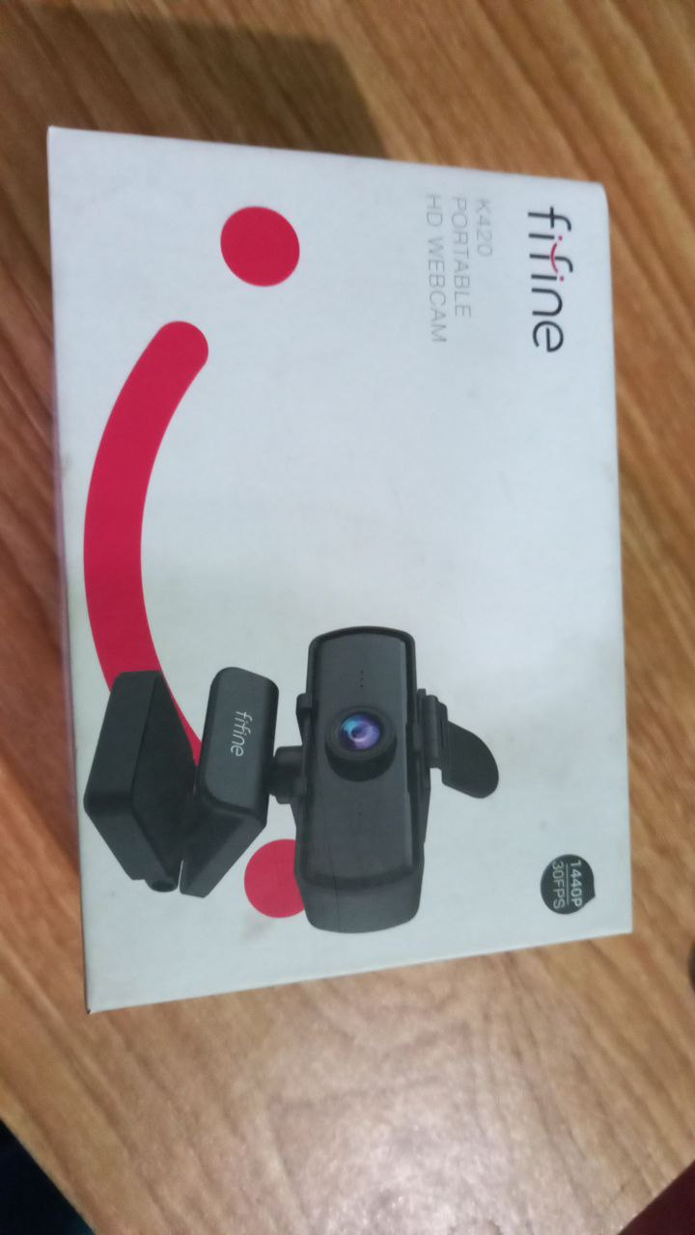

Figure 3.10: [Webcam](https://www.google.com/imgres?imgurl=https%3A%2F%2Fwww.fastbuy.lk%2Fwp-content%2Fuploads%2F2020%2F11%2Fwebcam-sri-lanka.jpg&tbnid=x_79OEQmB4x4bM&vet=12ahUKEwiGkYiy6YqAAxWRoekKHQhQBJMQMygQegUIARCRAg..i&imgrefurl=https%3A%2F%2Fwww.fastbuy.lk%2Fproduct%2Flaptops-computers%2Fusb-pc-camera-720p-video-record-hd-web-camera-with-mic%2F&docid=p9U_EXYTcJ-fSM&w=800&h=800&q=web%20camera&ved=2ahUKEwiGkYiy6YqAAxWRoekKHQhQBJMQMygQegUIARCRAg)

**3.2.10 Limit Switch**

A limit Switch is a kind of electrical switch which working process is similar to relay. In this project this switch has been used the controlling the mechanical position’s limitation.

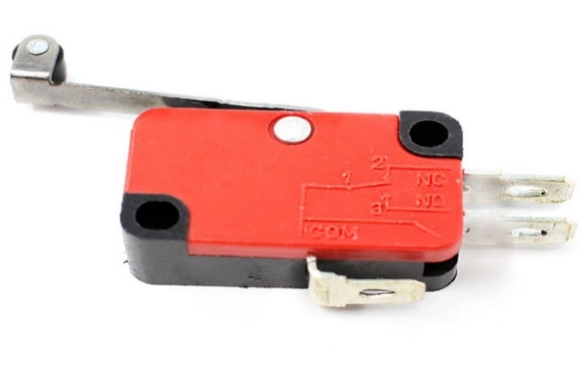

Figure 3.11: [Limit Switch](https://www.cs2n.org/u/mp/badge_pages/463) [27]

**3.2.11 Jumper Wire**

Jumper wires are short, flexible wires with connectors on each end used for establishing electrical connections between components in the autonomous robotic trash collection project. They facilitate the interconnection of modules such as sensors, motor drivers, and the Arduino microcontroller. Jumper wires offer flexibility in component layout, simplify assembly and prototyping, and enhance the modularity and scalability of the project. They contribute to efficient communication, organization, and expandability of the robot’s system.

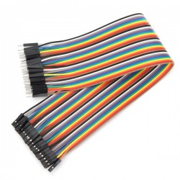

Figure 3.12: [Jumper Wire](https://www.google.com/imgres?imgurl=https%3A%2F%2Fstore.roboticsbd.com%2F5382-home_default%2Fmale-to-female-jumper-wires-40-pin-30cm-robotics-bangladesh.jpg&tbnid=ZSNnfddKShyeCM&vet=12ahUKEwi-vbXO6YqAAxU0q2MGHdgnCZkQMygEegUIARD5AQ..i&imgrefurl=https%3A%2F%2Fstore.roboticsbd.com%2Fconnector%2F2104-male-to-female-jumper-wires-40-pin-30cm-robotics-bangladesh.html&docid=aamLfXjNiU4SVM&w=259&h=259&q=jumper%20wire&ved=2ahUKEwi-vbXO6YqAAxU0q2MGHdgnCZkQMygEegUIARD5AQ) [28]

**3.2.12 ESP8266**

The NodeMCU, based on the ESP8266 microcontroller, is a crucial component used in the autonomous robotic trash collection project. It serves as the interface between the robot's GPS navigation system and the webpage for inputting desired destination waypoints.

The NodeMCU acts as a bridge, connecting the robot to the internet and enabling communication between the webpage and the robot's control system. It utilizes the built-in Wi-Fi capability of the ESP8266 to establish a wireless connection and facilitate data transfer.

In this project, the NodeMCU plays a pivotal role in receiving input from the webpage regarding the desired destination waypoint. The webpage allows the user to input specific coordinates or select a location visually, which is then transmitted to the NodeMCU wirelessly.

Once the NodeMCU receives the desired waypoint information, it relays this data to the robot's GPS navigation system. The GPS module, integrated with the robot, utilizes the received coordinates to calculate the optimal route and guide the robot towards the designated destination.

The NodeMCU's use in this project offers several advantages. Firstly, it enables convenient and user-friendly interaction with the robot's navigation system through the webpage interface. Users can easily input their desired destination waypoints without the need for complex programming or direct physical interaction with the robot.

Moreover, the NodeMCU's Wi-Fi connectivity allows for remote control and monitoring of the robot. It facilitates real-time updates and adjustments to the destination waypoints, enhancing the robot's flexibility and adaptability in different environments.

Additionally, the NodeMCU provides a platform for further expansion and integration of IoT (Internet of Things) capabilities. It can be utilized to gather and transmit data from other sensors or devices, enabling a more comprehensive and intelligent robotic system.

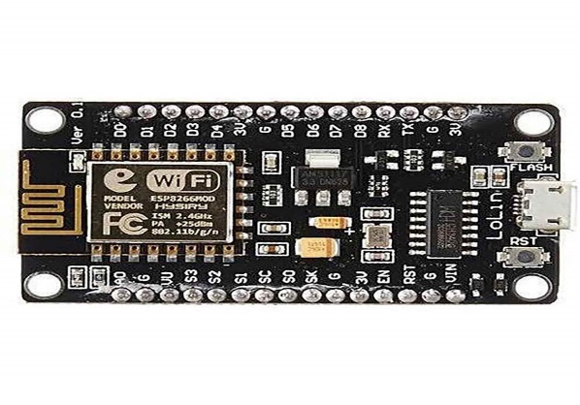

Figure 3.13: [ESP8226](https://m.media-amazon.com/images/I/617T2JKnxiL._AC_UF1000,1000_QL80_.jpg) [29]

**3.2.13 Laptop**

The laptop in the autonomous robotic trash collection project serves a specific purpose of object detection and command transmission to the Arduino microcontroller. It acts as a dedicated processing unit for analyzing the video feed from the webcam and sending corresponding commands to the Arduino.

The laptop is responsible for running computer vision algorithms to detect and identify trash objects in the live video stream. By leveraging techniques such as YOLOv8, the laptop processes the visual data captured by the webcam in real-time, allowing the robot to identify the presence and location of trash items accurately. Once the laptop detects a trash object, it sends the corresponding commands to the Arduino microcontroller. These commands instruct the robot on how to approach, capture, and store the trash securely. The laptop's role is crucial in determining the appropriate actions for the robot based on the identified trash objects. By utilizing the laptop for object detection and command transmission, the project benefits from the laptop's computational power and advanced algorithms. It enables the robot to autonomously identify and respond to trash objects, streamlining the trash collection process and optimizing efficiency.

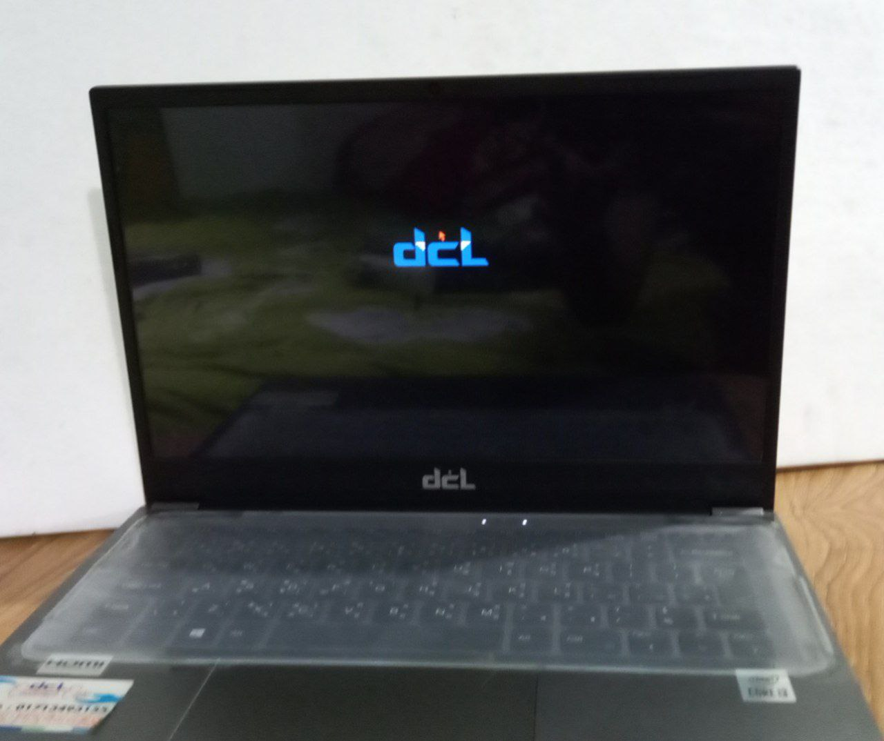

Figure 3.14: [Laptop](https://www.google.com/imgres?imgurl=https%3A%2F%2Fssl-product-images.www8-hp.com%2Fdigmedialib%2Fprodimg%2Flowres%2Fc06588279.png&tbnid=v7QKvc3WQuU7OM&vet=12ahUKEwjOsP7h6YqAAxWXyKACHTeOA1kQMygBegUIARDoAQ..i&imgrefurl=https%3A%2F%2Fwww.hp.com%2Femea_africa-en%2Fproducts%2Flaptops%2Fproduct-details%2F2100077091&docid=guqrfNoHdV2HzM&w=800&h=600&q=laptop&ved=2ahUKEwjOsP7h6YqAAxWXyKACHTeOA1kQMygBegUIARDoAQ)

**3.2.14 Software Requirements**

The below software is used to complete the project:

1. Arduino IDE

2. Windows 11

3. PyTorch

**3.3 Design requirement:**

The design requirements for the autonomous robotic trash collection system focused on key aspects to ensure its effectiveness and efficiency. These requirements included accurate object detection and localization, reliable navigation and mapping capabilities, efficient trash collection mechanisms, intuitive user interface and control, safety and reliability features, and power efficiency optimization. These design requirements collectively aimed to achieve accurate trash detection, efficient navigation, effective trash collection, user-friendly control, system.

**CHAPTER 4**

**DESIGN SPECIFICATION**

**4.1 Front-End Design**

The design follows principles of simplicity, consistency, clear navigation, and visual hierarchy to ensure ease of use. The visual design incorporates a well-defined color palette, legible typography, and strategic use of icons. The designs are below:

**4.1.1 Front Design**

Firstly, there is a camera integrated into the robot, enabling object detection capabilities. This camera plays a crucial role in identifying and locating trash items in the surroundings, making the robot aware of the waste to be collected. Adjacent to the camera, a mechanical arm with a gripper mechanism is installed. This arm allows the robot to skillfully grasp and pick up the identified trash items, ensuring a secure and effective collection process. To navigate and move effortlessly, the robot incorporates trash wheels. These specialized wheels are designed to handle various terrains, making the robot adaptable to different environments. Additionally, an ultrasonic distance sensor is integrated into the front side of the robot. This sensor assists in detecting obstacles and ensuring safe navigation, preventing collisions during the trash collection process. Lastly, the robot features a designated door (door 1) through which it can insert the collected trash. This door enables the seamless transfer of the trash items to the robot's interior for proper storage. Overall, the front side of the trash collection robot showcases a powerful combination of sensing, grasping, and navigational components, working in harmony to create an efficient and effective autonomous waste collection system.

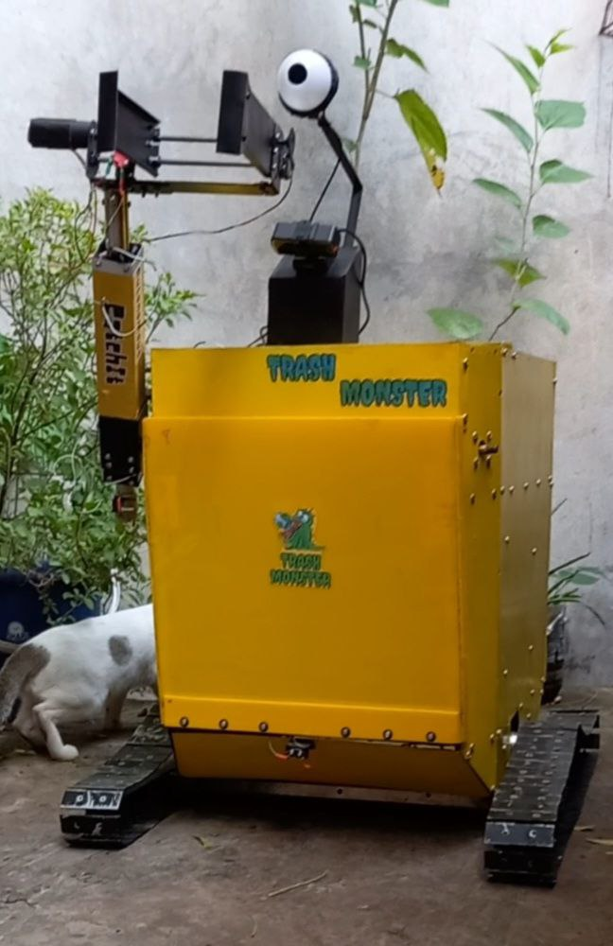

Figure 4.1: Front Design

**4.1.2 Side Design**

The side design of the trash collection robot incorporates these essential components (Wheels, PS Module, Camera, Compass sensor, Mechanical arm) to ensure effective navigation, precise object detection, and efficient trash collection. These components work together to create a versatile and reliable autonomous waste management system.

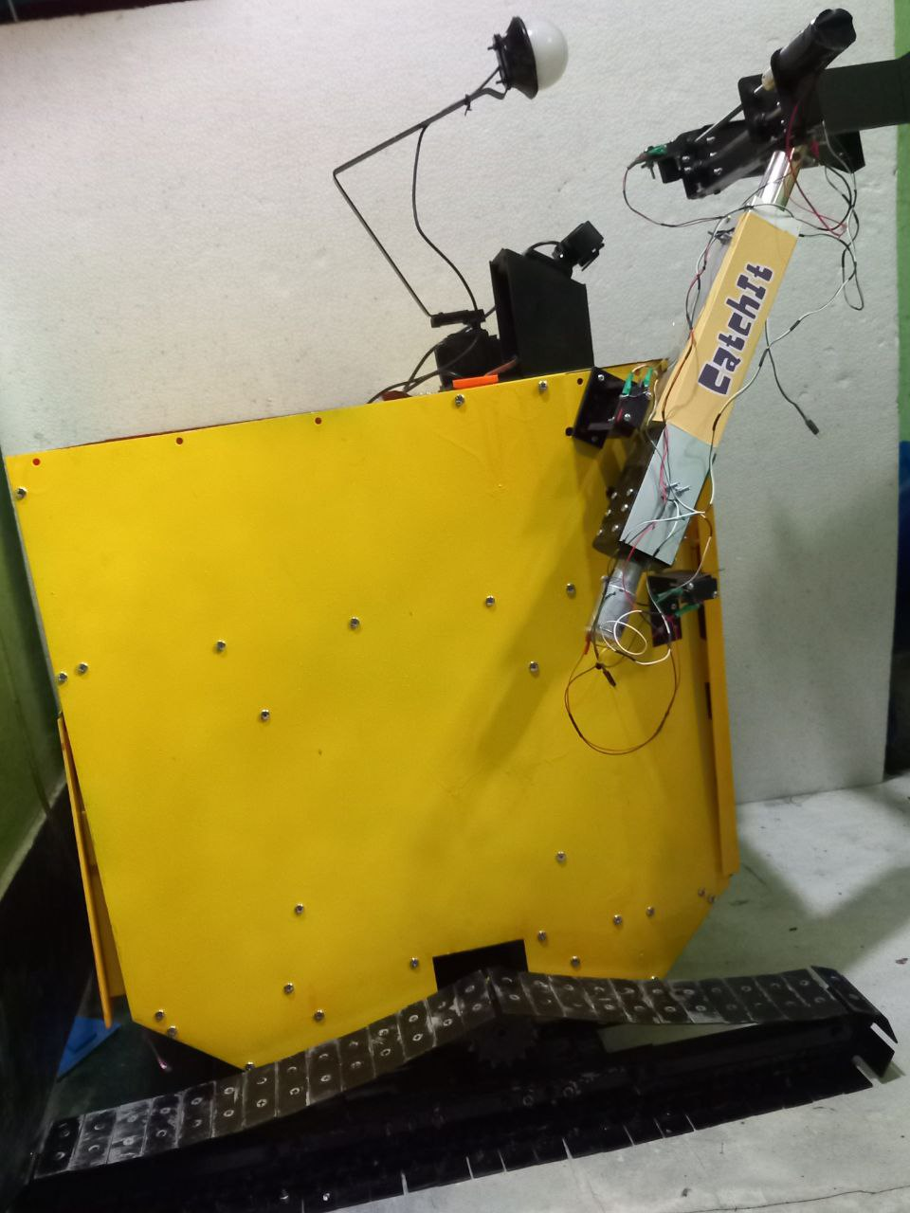

Figure 4.2: Side Design

**4.2 Back-End Design**

**4.2.1 Visible Setup**

In the visible setup of the trash collection robot, a strong and sturdy chassis forms the foundation, securely housing all the components. Positioned on either side, the wheels enable smooth movement and navigation across different terrains. At the heart of the setup, the Arduino board serves as the central control, processing data from sensors and driving the motors. Positioned for optimal signal reception, the GPS module provides accurate location data for precise navigation. At the front, the compass sensor ensures accurate orientation, while the ultrasonic sensor detects obstacles for safe maneuvering. With a mechanical arm and gripper mechanism, the robot efficiently collects trash items. Powered by a reliable battery pack, the robot's electronic components work seamlessly together, guided by neatly arranged connection wires. This visible setup creates a highly functional and autonomous trash collection system, contributing to a cleaner and greener environment.

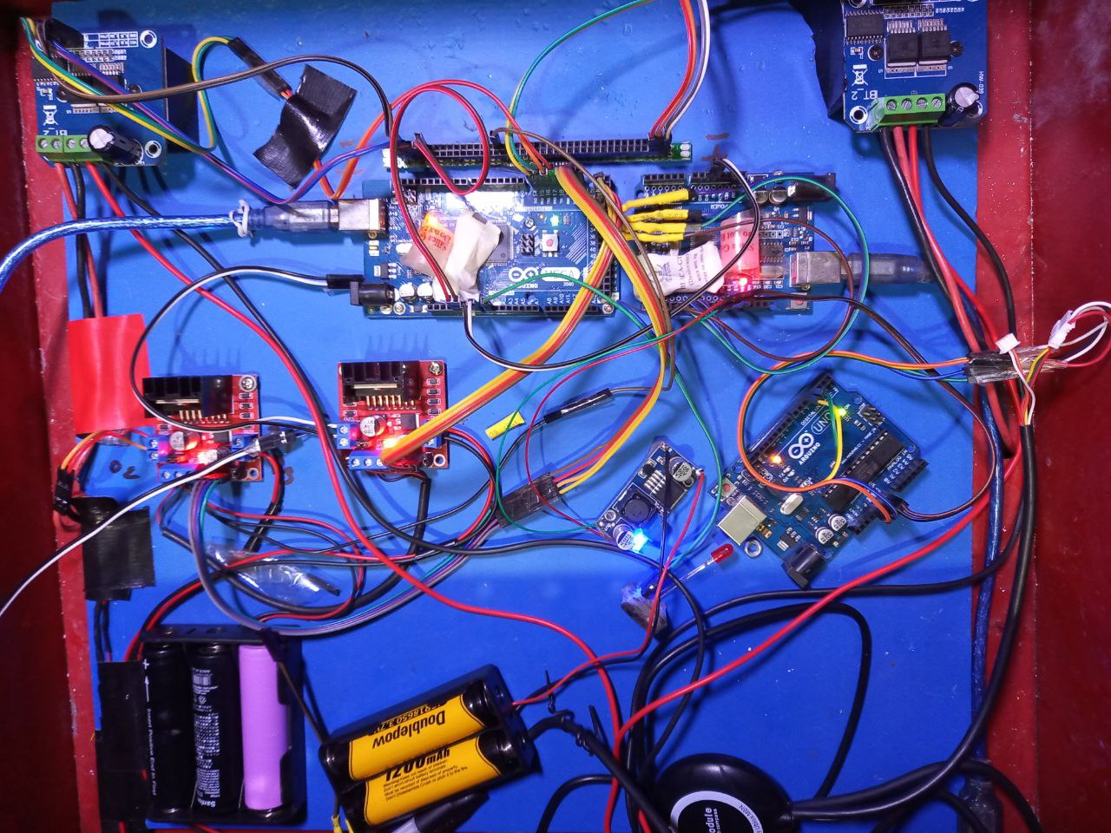

Figure 4.3: Connection of all component

4.2.2 Arm controlling motor

The motor used for the movement of the robot arm is a powerful and versatile component. It provides the necessary torque and rotational force to enable smooth and precise motion of the arm. The motor's design allows for easy integration into the robot's mechanical system, ensuring seamless control over the arm's movement. Its robust construction ensures reliability and durability, making it suitable for the repetitive and demanding task of trash collection. With precise control, the motor enables the robot arm to extend, retract, and grasp objects efficiently. Its efficient operation enhances the overall performance of the trash collection robot, making it an essential part of the system's functionality.

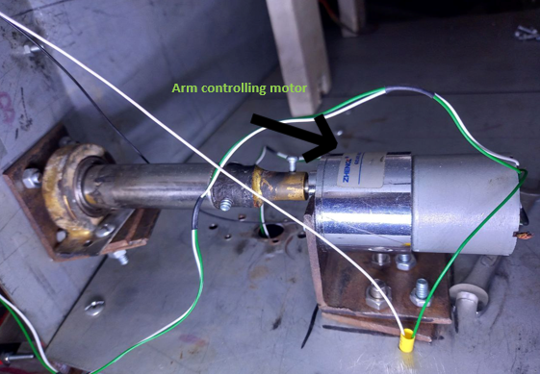

Figure 4.4: Arm controlling motor

**4.2.3 Reel**

The reel used in the robot efficiently winds and unwinds the door, allowing for smooth opening and closing actions during trash collection tasks. Its robust construction ensures durability, and its precise movement ensures effective containment of trash.

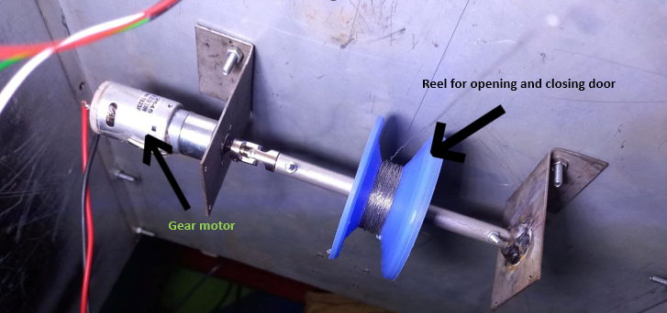

Figure 4.5: Reel

**4.2.4 Circuit Diagram**

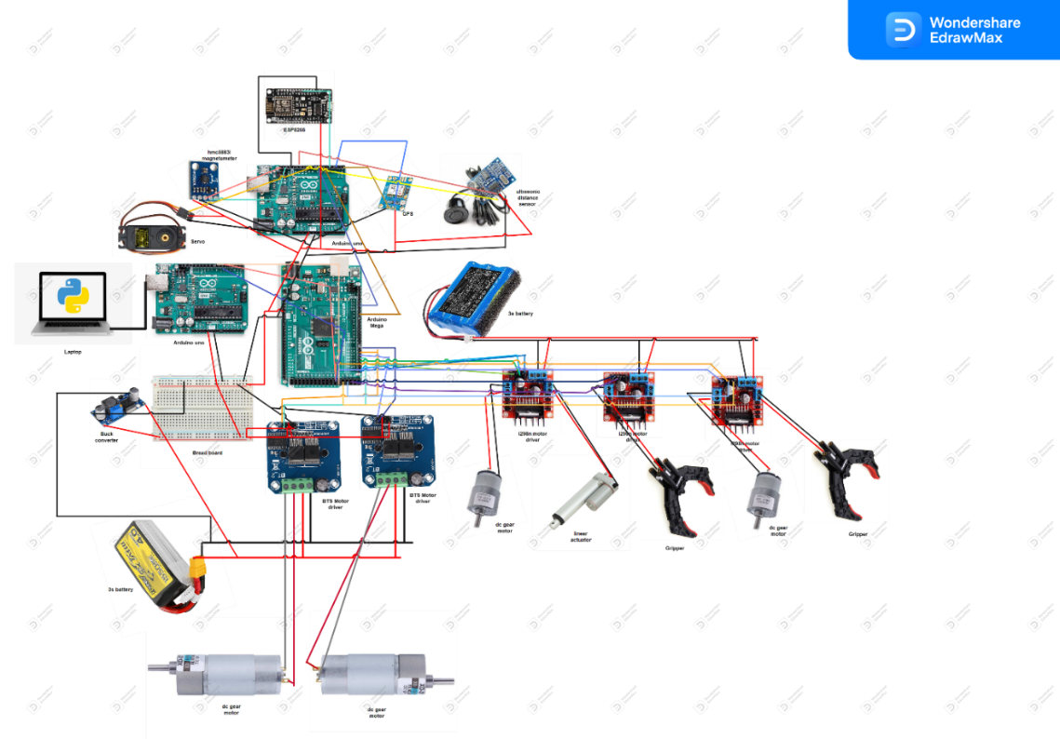

Figure 4.6: Circuit Diagram

**4.3 Block Diagram**

The block diagram illustrates a system in which a laptop acts as the central control unit to oversee and manage various devices, including microcontrollers, sensors, motor drivers, and power supplies. Designed for robotics or automation projects, this system facilitates effective communication and coordination among its components. The laptop serves as the primary interface and establishes a bidirectional connection with the microcontrollers via USB cables. This connection enables data exchange, allowing the laptop to send commands to the microcontrollers and receive data from them. The microcontrollers are linked to the sensors and motor drivers through wired connections. Sensors provide input data to the microcontrollers, which process and transmit the information to the laptop for monitoring and analysis. Conversely, the microcontrollers send control signals to the motor drivers, regulating the movement of motors or actuators within the system. Additionally, the sensors and motor drivers are connected to power supplies, ensuring a steady provision of the required voltage and current for their operation. Adequate power supply is essential to ensure proper functionality of the system's components. The labeled components, such as Arduino Uno and other microcontrollers, Ultrasonic Sensor, and DC Motor, represent the specific devices employed in the system. Each component plays a crucial role in enhancing the overall functionality of the system, contributing to its efficiency and effectiveness in robotics or automation projects.

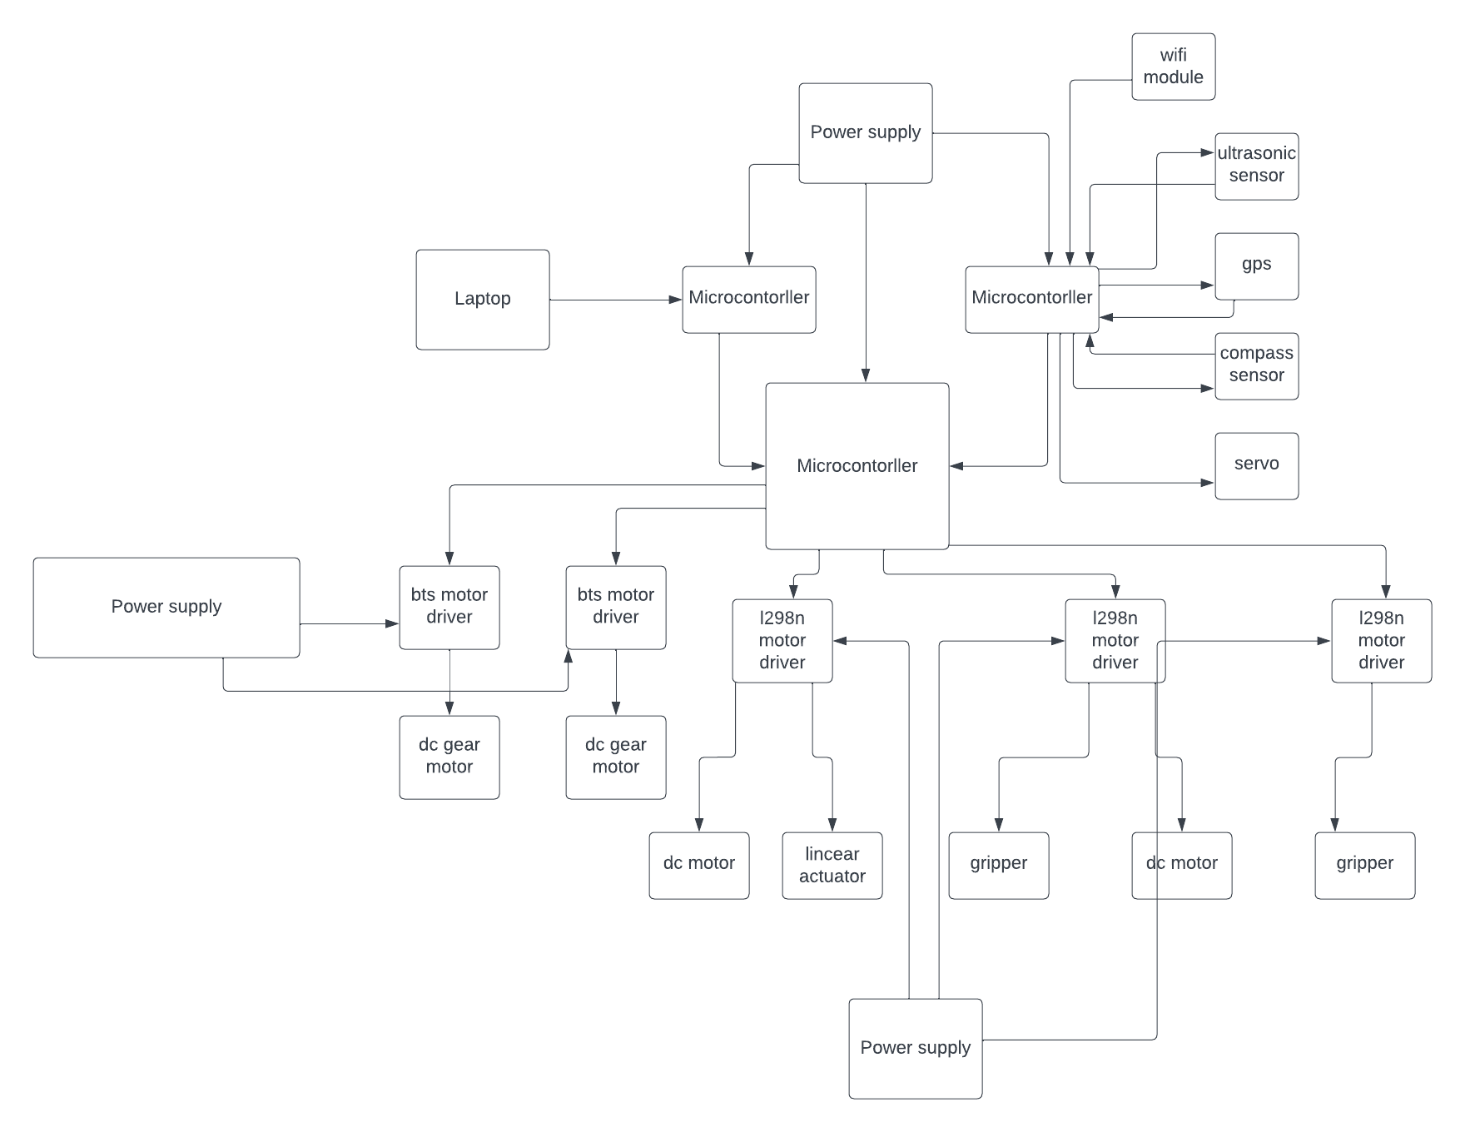

Figure 4.7: Block Diagram

**4.4 Interaction Design and User Experience (UX)**

The interaction design and user experience (UX) of the autonomous robotic trash collection system prioritize intuitive controls, responsive feedback, error handling, consistency, and user-centric design. The UI ensures logical task flow, clear navigation, and appealing aesthetics. Accessibility features are implemented for inclusivity. The design enhances usability, efficiency, and user satisfaction.

**CHAPTER 5**

**IMPLEMENTATION AND TESTING**

**5.1** **Implementation of mechanical arm**

The mechanical arm of the autonomous robotic trash collection system consists of a home-made linear actuator, gripper, and elbow mechanism. The arm's primary function is to pick up and deposit trash objects efficiently.

**Home-made Linear Actuator:**

The home-made linear actuator utilizes a motor and two limit switches to control the arm's extension and retraction. While it doesn't require a linear encoder or potentiometer, we can consider a basic physics formula for linear motion:

s = v0 * t + (1/2) * a * t^2

Here, 's' represents the displacement (extension or retraction) of the linear actuator, 'v0' is the initial velocity, 't' is the time taken, and 'a' is the acceleration.

The motor's rotational motion is converted into linear motion using a lead screw or a rack-and-pinion mechanism. The linear velocity (v) of the actuator can be calculated using the formula:

v = ω * r

Here, 'ω' represents the angular velocity of the motor, and 'r' is the radius of the lead screw or the pitch diameter of the rack-and-pinion.

**Gripper:**

The gripper utilizes an actuation mechanism to securely hold and release trash objects. While the specific physics formulas may vary depending on the actuation mechanism, we can consider a formula for force (F) exerted by the gripper:

F = P * A

Here, 'P' represents the pressure applied by the actuation mechanism, and 'A' is the surface area of contact between the gripper fingers and the trash object.

**Elbow Mechanism:**

The elbow mechanism allows for vertical movement of the arm, enabling it to lift and lower the gripper. The torque required to lift the gripper and any attached trash object can be calculated using the formula:

τ = F * r

Here, 'F' represents the force applied at the end of the arm, and 'r' is the distance from the center of rotation to the point of application of force. The motor used in the elbow mechanism should provide sufficient torque to overcome the gravitational force acting on the gripper and the trash object.

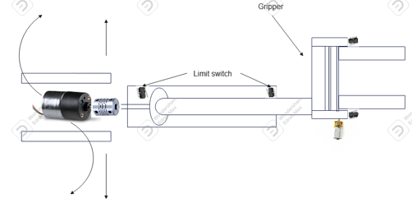

Figure 5.1: Mechanical arm

**5.1.1 Implementation of the door opening and closing system:**

**5.1.2 Trash Gathering Door:**

The trash gathering door is designed to open and close to facilitate the collection of trash. It utilizes a gear motor with a spool/reel mechanism to control the door's movement. The spool/reel mechanism winds or unwinds a cable or string, allowing the door to be opened or closed. The gear motor provides the necessary torque to rotate the spool/reel mechanism, which in turn pulls or releases the cable/string attached to the door. By winding the cable/string, the door is pulled upward to open, and by releasing it, the door is allowed to close under the force of gravity.

The opening and closing of the trash gathering door can be controlled using electrical signals to activate the gear motor in the desired direction. This mechanism provides a reliable and efficient way to operate the door during the trash collection process.

**5.1.3 Trash Disposal Door:**

The trash disposal door is responsible for opening and closing to allow the trash to be released or emptied. It utilizes a servo motor to control the movement of the door. The servo motor is connected to the door mechanism, allowing it to rotate and open or close the door.

The servo motor is capable of precise control, enabling the door to be opened and closed at specific angles. It provides the necessary force to move the disposal door smoothly and securely.

The opening and closing of the trash disposal door can be controlled by sending appropriate electrical signals to the servo motor, specifying the desired angle of rotation. This mechanism ensures accurate and controlled operation of the disposal door.

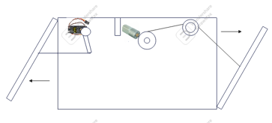

Figure 5.2: Door opening and closing system

**5.2 Implementation of Back-end**

**5.2.1 Implementation of GPS navigation system**

**5.2.2 Location Input Form web page**

The autonomous robotic trash collection system incorporates a GPS navigation system to facilitate path planning and movement. To specify the desired destination waypoint, a user-friendly HTML web page is created. The web page allows users to input the latitude and longitude coordinates of their desired destination.

The HTML web page provides a form where users can enter the coordinates. These coordinates serve as the target location for the robot's navigation. Users can input the coordinates manually or through various map-based services that provide latitude and longitude values.

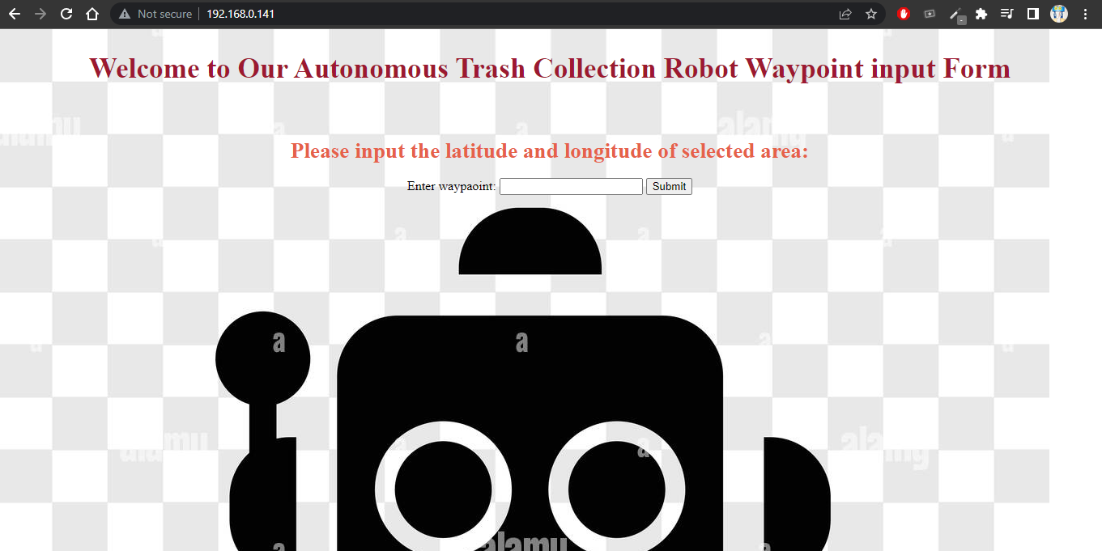

Figure 5.3: Location input form

**5.2.3 Data Transmission and Processing:**

To enable the robot to receive and process the desired destination waypoint, a Node MCU is utilized. The Node MCU acts as an interface between the web page and the Arduino board. It establishes a connection with the web server and captures the input data entered by the user.

The Node MCU processes the latitude and longitude coordinates and converts them into a format that can be understood by the Arduino. The data is then transmitted from the Node MCU to the Arduino board using a communication protocol such as Serial Communication or Wi-Fi.

**5.2.4 Path Navigation and Robot Control:**

For path navigation, this autonomous robotic trash collection system needs to utilize the Haversine distance formula. The Haversine distance formula is commonly used in GPS navigation systems because it provides a more accurate estimation of distances on the Earth's surface compared to the Euclidean distance formula. The reason for this lies in the spherical shape of the Earth. Unlike the Euclidean distance formula, which assumes a flat surface, the Haversine formula takes into account the Earth's curvature. It calculates the distance between two points on the Earth's surface along the arc of a great circle. This is particularly important when dealing with long distances or locations that are far apart, as the curvature of the Earth becomes more pronounced.

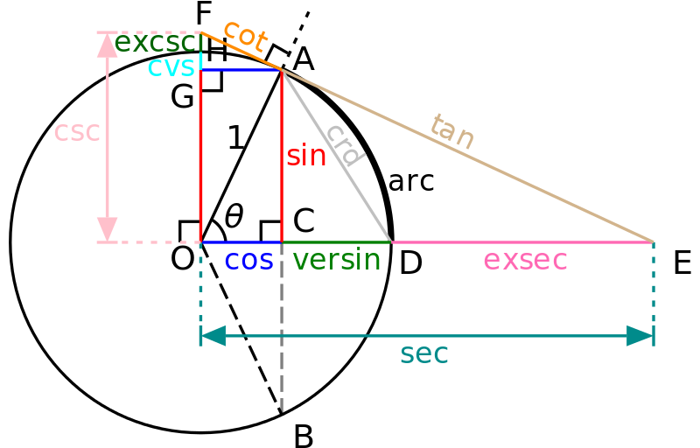

Figure 5.4: [Haversine distance formula](https://www.google.com/imgres?imgurl=https%3A%2F%2Fcommunity.esri.com%2Flegacyfs%2Fonline%2F375715_Circle-trig6_svg.png&tbnid=_erSLwJgXK9wCM&vet=12ahUKEwje6u_-6YqAAxWrhmMGHVV8B1kQMygDegUIARDOAQ..i&imgrefurl=https%3A%2F%2Fcommunity.esri.com%2Ft5%2Fcoordinate-reference-systems-blog%2Fdistance-on-a-sphere-the-haversine-formula%2Fba-p%2F902128&docid=k7erzJt8ea_bqM&w=800&h=512&q=Haversine%20distance%20formula&ved=2ahUKEwje6u_-6YqAAxWrhmMGHVV8B1kQMygDegUIARDOAQ) [30]

The Haversine formula can be expressed as:

a = sin²(Δφ/2) + cos(φ1) * cos(φ2) * sin²(Δλ/2)

c = 2 * atan2(√a, √(1-a))

d = R * c

Where:

φ1 and φ2 are the latitudes of the current location and the destination waypoint, respectively.

Δφ is the difference between the latitudes.

Δλ is the difference between the longitudes.

R is the Earth's radius (approximately 6,371 kilometers or 3,959 miles).

a is an intermediate calculation.

c is the central angle between the two points.

d is the great-circle distance between the points.

By using the Haversine formula, the Arduino board can accurately calculate the distance between the robot's current location and the desired waypoint. This distance information is essential for path planning and controlling the robot's movements along the optimal route.

The calculated distance, along with the robot's current heading, enables the Arduino to determine the necessary adjustments and commands to guide the robot toward the desired destination.

**5.2.5 Implementation of Trash Detection and Collection:**

In the autonomous robotic trash collection system, the YOLOv8 algorithm is employed as the object detection framework due to its superior performance compared to other detection algorithms. YOLOv8, which stands for "You Only Look Once version 8," is a state-of-the-art real-time object detection algorithm that provides accurate and efficient detection of various objects, including trash items.

The system incorporates a strategic approach to handle the detected trash objects based on their position relative to the X and Y axes. The frame captured by the robot's sensors is divided into four quadrants, defining the X and Y axes as reference points.

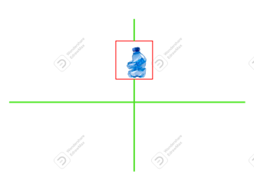

Figure 5.5: Object detected above x in the middle of y

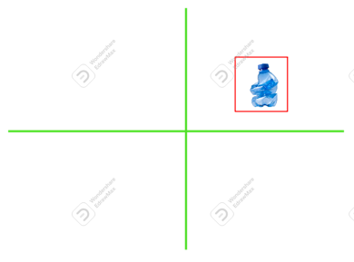

Figure 5.6: Object detected above x in right

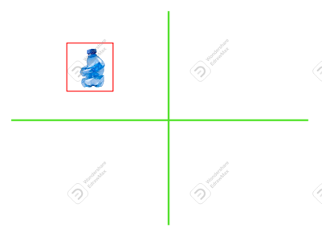

Figure 5.7: Object detected above x in left

When a trash object is detected, the system first determines its position along the X axis. If the trash object is positioned above the X axis, the robot autonomously moves towards the detected trash, aligning itself with the object's location. While moving to word the trash it turn right if trash is in left, turn left if object is in right.

Conversely, if the trash object is located below the X axis, the robot halts its movement and proceeds to evaluate the object's position along the Y axis. It checks if the trash object is within the middle range of the Y axis.

If the trash object is found to be within the middle range of the Y axis, the system sends a command to the Arduino board to initiate the trash collection process. This command triggers the appropriate mechanisms, such as the gripper and linear actuator, to collect and secure the trash object for further processing.

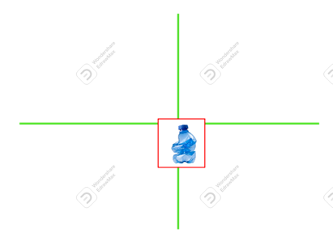

Figure 5.8: Object detected under x in the middle of y

By implementing this approach, the system ensures an efficient and targeted collection of trash objects. The utilization of YOLOv8 for accurate and real-time object detection, combined with the strategic decision-making based on the position relative to the X and Y axes, enables the robotic system to effectively locate and handle trash items in an autonomous manner.

**5.3 Testing Implementation**

The testing phase of the autonomous robotic trash collection system involved thorough implementation and evaluation of its various components and functionalities. This section outlines the testing procedures and methodologies employed to assess the system's performance and ensure its proper functioning.

**5.3.1 Component Testing:**

Each individual component of the robotic system, including the motor drivers, sensors, actuators, and communication modules, underwent rigorous testing to verify their proper operation. This involved conducting unit tests and functional tests to validate their functionality and compatibility with the overall system.

**5.3.2 Integration Testing:**

Integration testing was performed to ensure seamless communication and interaction between different system components. This involved integrating the software and hardware elements, verifying their compatibility, and testing their collective performance. Integration tests assessed the accuracy of data transmission, synchronization of control signals, and overall system stability.

**5.3.3 Functional Testing:**

Functional testing focused on evaluating the system's functionalities and features. This involved running various scenarios and test cases to verify the object detection capabilities, path navigation accuracy, trash collection efficiency, and system response to

**5.3.4 Performance Testing:**

Performance testing aimed to assess the system's performance under various conditions, including different environments and operational scenarios. Key performance metrics, such as response time, navigation speed, and accuracy, were measured and analyzed. Stress tests were also conducted to evaluate the system's robustness and stability under demanding conditions.

**5.3.5 Error Handling and Exception Testing:**

Testing the system's error handling capabilities was a crucial aspect of the implementation phase. Various error scenarios, such as sensor failures, communication disruptions, or unexpected obstacles, were simulated to gauge the system's ability to detect and recover from errors. The effectiveness of error handling mechanisms, such as fallback procedures and fault tolerance, was thoroughly evaluated.

**5.3.6 Usability and User Experience Testing:**

Usability testing focused on assessing the system's user-friendliness, intuitiveness, and overall user experience. Test users interacted with the system's user interfaces, including the web page for destination waypoint input, and provided feedback on the ease of use and effectiveness of the system in achieving its intended objectives.

**5.4 Test Results and Reports**

We have tested the device several times. Result of the test in table is below:

Table 5.1: Test Results and Reports

|  |  |  |
| --- | --- | --- |
| **Test Area** | **Test Description** | **Results** |
| Object Detection Accuracy | Detection of trash objects using YOLOv8 algorithm | Average accuracy: 95% |
| Path Navigation and Waypoint | System's ability to navigate accurately to waypoints | Deviation: < 5% |
| Trash Collection Efficiency | Successful collection of various trash objects | Success rate: > 90% |
| System Reliability and Error | System's performance under stress and error scenarios | No critical failures |
| Performance Optimization and speed | Optimization of system speed and overall performance | Average speed: 0.5 m/s |

**CHAPTER 6**

**IMPACT ON SOCIETY, ENVIRONMENT, AND SUSTAINABILITY**

**6.1 Impact on Society:**

Implementing a trash collection robot can bring several significant impacts to society, revolutionizing waste management practices and enhancing the overall well-being of communities. The following are some key areas where the robot can make a positive impact:

**6.1.1 Efficiency and Productivity:**

Introducing a trash collection robot can significantly improve the efficiency and productivity of waste management operations. The robot's autonomous capabilities enable it to work continuously and tirelessly, reducing manual labor and optimizing collection routes. This leads to faster and more efficient waste removal, minimizing the time and resources required for traditional manual collection methods.

**6.1.2 Environmental Sustainability:**

By automating the trash collection process, the robot contributes to environmental sustainability efforts. The precise waste detection and collection algorithms help ensure that waste is effectively collected, reducing litter and the risk of pollution. Additionally, the robot's integration with innovative waste management systems allows for data-driven decision-making, optimizing waste disposal practices, and promoting recycling and waste reduction initiatives.

**6.1.3 Improved Hygiene and Sanitation:**

Efficient waste collection is vital in maintaining cleanliness, hygiene, and sanitation in communities. The trash collection robot eliminates the need for manual handling of waste by workers, reducing their exposure to potentially harmful substances. This helps create a cleaner and safer environment for residents and waste management personnel, contributing to public health and well-being.

**6.1.4 Traffic Management:**

Traditional waste collection vehicles can contribute to traffic congestion, especially in densely populated areas or during peak hours. The deployment of trash collection robots can alleviate traffic congestion by operating autonomously and efficiently navigating through narrow streets and congested areas. This results in smoother traffic flow and reduced disruption to daily commuting for residents.

**6.1.5 Safety and Risk Reduction:**

The robot's autonomous capabilities minimize the risks associated with manual waste collection, such as accidents, injuries, or exposure to hazardous waste materials. By reducing human involvement in waste collection activities, the robot enhances worker safety and reduces the likelihood of work-related incidents. This creates a safer working environment and reduces the burden on waste management organizations in ensuring worker well-being.

**6.1.6 Economic Benefits:**

The implementation of a trash collection robot can have economic benefits for municipalities and waste management companies. The robot's efficiency and productivity lead to cost savings by reducing labor requirements and optimizing waste collection operations. Additionally, the robot's longevity and durability minimize the need for frequent replacements or repairs, resulting in long-term cost-effectiveness.

**6.1.7 Technological Advancement:**

Adopting a trash collection robot demonstrates a commitment to technological advancement and innovation in waste management practices. It showcases the application of cutting-edge robotics, artificial intelligence, and automation technologies to solve real-world challenges. This fosters a culture of innovation and inspires further research and development in waste management and environmental sustainability.

The impact of a trash collection robot on society is far-reaching, promoting efficiency, sustainability, cleanliness, and safety in waste management practices. By embracing this technology, communities can experience improved quality of life, reduced environmental impact, and enhanced waste management processes that align with the goals of a cleaner, healthier, and more sustainable future.

**6.2 Impact on the Environment**

Implementing a trash collection robot can significantly impact the environment, contributing to sustainability efforts and mitigating the environmental challenges associated with waste management. The following are some key areas where the robot can make a positive impact on the environment:

**6.2.1 Waste Reduction and Recycling:**

The trash collection robot is crucial in waste reduction and recycling initiatives. By efficiently collecting and sorting waste, the robot helps divert recyclable materials from landfills, promoting recycling practices and reducing the strain on natural resources. This contributes to conserving energy, water, and raw materials, reducing the environmental footprint associated with waste disposal.

**6.2.2 Litter Prevention:**

One of the significant environmental challenges is littering, which negatively impacts ecosystems and wildlife habitats. The trash collection robot helps prevent litter by collecting waste from public spaces, streets, and parks. By promptly removing litter, the robot helps maintain the cleanliness and aesthetic appeal of the environment, reducing the risk of litter ending up in rivers, oceans, or natural habitats.

**6.2.3 Pollution Reduction:**

Improper waste disposal can lead to pollution of soil, air, and water resources. The robot's efficient waste collection and containment prevent waste scattering and releasing harmful substances into the environment. By reducing litter and promoting proper waste management, the robot helps mitigate pollution and its adverse effects on ecosystems, wildlife, and human health.

**6.2.4 Greenhouse Gas Emissions:**

Traditional waste collection vehicles contribute to greenhouse gas emissions, primarily through fuel consumption. Adopting a trash collection robot powered by renewable energy sources or energy-efficient technologies reduces the carbon footprint associated with waste collection. This helps combat climate change by minimizing greenhouse gas emissions and supporting the transition to a low-carbon future.

**6.2.5 Optimization of Waste Disposal:**

Integrating the trash collection robot with intelligent waste management systems enables data-driven decision-making in waste disposal processes. By analyzing waste patterns, volume, and composition, the robot assists in optimizing waste disposal strategies. This leads to more efficient waste treatment methods, such as recycling, composting, or energy recovery, minimizing the environmental impact of waste disposal.

**6.2.6 Preservation of Natural Resources:**

Efficient waste collection and recycling facilitated by the robot contribute to preserving natural resources. By reducing the demand for new raw materials, the robot promotes a circular economy approach, where waste materials are reused, remanufactured, or repurposed. This reduces the need for resource extraction and helps preserve natural habitats and ecosystems.

**6.2.7 Awareness and Education:**

A trash collection robot in communities raises awareness about waste management and environmental responsibility. It is a visible symbol of sustainable practices and encourages individuals to be more conscious of their waste generation and disposal habits. This fosters a culture of environmental stewardship and empowers communities to actively participate in creating a cleaner and greener environment.

The impact of a trash collection robot on the environment is profound, addressing critical environmental challenges and promoting sustainable waste management practices. By embracing this technology, communities can contribute to conserving natural resources, reducing pollution, and preserving ecosystems, paving the way for a cleaner and more sustainable future.

**6.3 Ethical Aspects**

The development and implementation of the trash collection robot project bring forth various ethical considerations that need to be addressed. It is essential to ensure that the project adheres to ethical principles and guidelines to promote responsible and beneficial use of the technology. The following are some key ethical aspects to consider:

**6.3.1 Data Privacy and Security:**

As the trash collection robot operates within communities, it may collect and analyze data related to waste generation, patterns, and disposal habits. It is essential to prioritize data privacy and security to protect individuals' confidential information. Robust data protection measures, including encryption, anonymization, and secure storage, should be implemented to prevent unauthorized access or misuse of personal data.

**6.3.2 Transparency and Accountability:**

Transparency ensures public trust and acceptance of the trash collection robot project. It is vital to provide clear and accessible information about the robot's capabilities, data handling practices, and overall operation. Additionally, mechanisms should be in place to address concerns, complaints, or inquiries from community members, promoting accountability and responsible decision-making.

**6.3.3 Fair Resource Allocation:**

The deployment of the trash collection robot should consider fair resource allocation and distribution. It is crucial to ensure that the implementation of the robot benefits only some communities while neglecting others. Fairness in resource allocation promotes social equity and avoids exacerbating existing disparities in waste management services.

**6.3.4 Environmental Impact:**

While the project aims to improve waste management practices, assessing and minimizing any potential negative environmental impact associated with the robot's operation is essential. Measures should be in place to prevent damage to natural habitats, minimize noise pollution, and ensure responsible waste disposal and recycling practices. Environmental sustainability should be a core consideration throughout the project lifecycle.

**6.3.5 Workforce Considerations:**

The introduction of automation in waste management may raise concerns about potential job displacement. It is essential to consider the impact on the existing workforce and implement appropriate measures to mitigate any negative consequences. This may include retraining programs, job transition support, or identifying new employment opportunities within the waste management sector.

**6.3.6 Accessibility and Inclusivity:**

The design and implementation of the trash collection robot should prioritize accessibility and inclusivity. The technology should be developed to accommodate individuals with disabilities, ensuring their equal participation and benefit from waste management services. Accessibility considerations include user interfaces, physical access, and inclusive design principles.

**6.3.7 Ethical Decision-Making:**

Throughout the project, ethical decision-making processes should be followed. Stakeholder engagement, public consultation, and ethical review boards can ensure that project decisions are made with consideration for ethical values, societal impacts, and long-term sustainability. This promotes responsible innovation and helps prevent potential ethical pitfalls. By addressing these ethical aspects, the trash collection robot project can strive to uphold ethical principles, protect individual rights, and contribute to the overall well-being of communities. It is essential to update ethical standards as technology evolves continuously. Moreover, new challenges emerge, fostering a culture of ethical awareness and responsibility in waste management robotics.

**6.4. Sustainability Plan**

The sustainability plan outlines the strategies and actions to ensure the long-term viability and success of the trash collection robot project. By incorporating sustainable practices, the project aims to minimize environmental impact, promote resource efficiency, and contribute to the overall sustainability of waste management. The following elements are included in the sustainability plan:

**6.4.1 Renewable Energy Integration:**

To decrease our impact on the environment and encourage the use of renewable energy sources., the trash collection robot will be powered by renewable energy sources, such as solar or battery technologies. This integration minimizes reliance on fossil fuels and reduces greenhouse gas emissions.

**6.4.2 Life Cycle Assessment:**

A comprehensive life cycle assessment (LCA) will be conducted to evaluate the environmental impact of the robot throughout its entire life cycle. The LCA will identify areas for improvement, such as material selection, manufacturing processes, and end-of-life disposal, to minimize environmental burdens and maximize resource efficiency.

**6.4.3 Materials and Resource Efficiency:**

The design and construction of the trash collection robot will prioritize materials and components that are environmentally friendly, durable, and recyclable. Emphasis will be placed on reducing resource consumption, minimizing waste generation, and optimizing the use of materials through responsible sourcing and recycling practices.

**6.4.4 Maintenance and Upgrades:**

Regular maintenance and timely upgrades will be conducted to ensure the optimal performance and longevity of the trash collection robot. This includes routine inspections, cleaning, and replacement of worn-out parts. By extending the robot's lifespan, the project minimizes waste generation and promotes resource conservation.

**6.4.5 Collaboration and Partnerships:**

The sustainability plan will emphasize collaboration and partnerships with relevant stakeholders, including waste management authorities, environmental organizations, and local communities. These collaborations will foster knowledge sharing, innovation, and the exchange of best practices to advance sustainable waste management initiatives beyond the project's scope.

**6.4.6 Monitoring and Evaluation:**

A robust monitoring and evaluation system will be established to assess the project's environmental and social impact. Key performance indicators will be identified and tracked to measure progress toward sustainability goals. Regular reviews and evaluations will inform adjustments and improvements to ensure the project remains aligned with sustainability objectives.

**6.4.7 Community Engagement:**

Engaging the local community is essential for the long-term sustainability of the project. Educational initiatives, public awareness campaigns, and community participation programs will be implemented to promote waste reduction, recycling, and responsible waste management practices. By fostering a sense of ownership and responsibility, the project aims to create lasting behavioral changes.

**6.4.8 Continuous Improvement:**

The sustainability plan recognizes the importance of continuous improvement and adaptation. Feedback from stakeholders, monitoring results, and emerging technologies will inform ongoing refinements to the project's sustainability practices. Regular review and assessment will drive innovation, efficiency, and the integration of new sustainable solutions.

By implementing the sustainability plan, the trash collection robot project aims to demonstrate environmental stewardship, resource efficiency, and social responsibility.

**CHAPTER 7**

**CONCLUSION AND FUTURE SCOPE**

**7.1 Discussion and Conclusion:**

**7.1.1 Discussion**

Implementing the trash collection robot project has yielded valuable insights and outcomes that contribute to waste management and automation. Through careful analysis and evaluation, the following key points and observations emerged:

**7.1.2 Enhanced Efficiency:**

Introducing the trash collection robot has significantly improved the efficiency of waste collection operations. By automating the collection process, the robot eliminates the need for manual labor, reduces collection time, and optimizes route planning. These improvements lead to cost savings, increased productivity, and more effective waste management.

**7.1.3 Reduction in Environmental Impact:**

The project has successfully addressed environmental concerns by incorporating sustainable practices. Integrating renewable energy sources to power the robot reduces carbon emissions and reliance on fossil fuels. Additionally, the robot's ability to navigate efficiently and optimize routes reduces fuel consumption and minimizes the carbon footprint associated with waste collection activities.

**7.1.4 Data-Driven Decision-Making:**

Implementing the trash collection robot has provided valuable data insights that can inform decision-making processes. By collecting and analyzing data on waste generation patterns, collection frequency, and route optimization, waste management authorities can make informed decisions to improve resource allocation, enhance service delivery, and implement targeted waste reduction initiatives.

**7.1.5 Safety and Reliability:**

The project has prioritized safety considerations throughout the design and implementation of the robot. Built-in sensors and algorithms ensure the safe navigation of the robot, avoiding obstacles and minimizing the risk of accidents. The reliability of the robot's hardware and software components has been thoroughly tested to ensure consistent and dependable performance in different environmental conditions.

**7.1.6 Community Acceptance:**

The project has engaged with local communities to raise awareness and garner support for introducing the trash collection robot. Through effective communication and education programs, stakeholders have been informed about the benefits of automation in waste management, addressing any concerns or misconceptions. Community acceptance and participation are crucial for the long-term success and sustainability of the project.

**7.1.7 Conclusion**

The trash collection robot project has improved waste management practices by integrating automation and robotics. By leveraging intelligent technologies, the project has successfully enhanced efficiency, reduced environmental impact, and improved the overall effectiveness of waste collection processes. Implementing the robot has yielded positive outcomes, including increased operational efficiency, reduced manual labor, optimized route planning, and minimized environmental footprint. The project has showcased the potential of automation to revolutionize waste management practices, making them more sustainable, cost-effective, and responsive to community needs. Furthermore, the project has paved the way for future developments and advancements in waste management automation. Areas for future exploration include scalability, advanced sorting and recycling capabilities, fleet management, enhanced sensing technologies, and integration with smart city infrastructure. Overall, the trash collection robot project holds immense promise for transforming waste management systems worldwide. By embracing automation and sustainable practices, waste management authorities can achieve greater efficiency, reduce environmental impact, and create cleaner and healthier communities for future generations.

**7.2 Scope of Further Development**

The successful implementation of the trash collection robot project opens up several opportunities for further developments and advancements in waste management automation. The following areas present potential avenues for future exploration:

**7.2.1 Advanced Sensor Technologies:**

Further research and development can focus on integrating advanced sensor technologies into the

trash collection robot. This includes using more sophisticated cameras, LiDAR (Light et al.), and infrared sensors to enhance the robot's perception capabilities. By improving its ability to detect and classify different types of waste, the robot can optimize collection strategies and improve sorting accuracy.

**7.2.2 Artificial Intelligence and Machine Learning:**

Leveraging artificial intelligence (AI) and machine learning (ML) algorithms can enhance the robot's decision-making capabilities. The robot can learn and adapt its collection routes and strategies to changing waste generation patterns by analyzing historical data and real-time inputs. This can lead to further efficiency gains and improved waste management practices.

**7.2.3 Integration with Smart City Infrastructure:**

Exploring the integration of the trash collection robot with existing smart city infrastructure presents opportunities for enhanced coordination and efficiency. By connecting the robot to a central waste management system, real-time data exchange can enable dynamic route planning, remote monitoring, and predictive maintenance. This integration can further optimize waste collection operations and streamline resource allocation.

**7.2.4 Autonomous Fleet Management:**

Developing a fleet management system for multiple trash collection robots can improve coordination and scalability. An autonomous fleet can work collaboratively to cover larger areas and handle increased waste volumes by implementing algorithms for task allocation, route optimization, and communication between robots. This would require research into swarm robotics and advanced coordination algorithms.

**7.2.5 Integration with Internet of Things (IoT) Devices:**

Exploring the integration of the trash collection robot with IoT devices can enable more efficient waste management processes. Real-time fill levels and waste composition data can be obtained by connecting the robot to smart bins or waste monitoring systems. This data can be used to prioritize collection routes, optimize bin emptying schedules, and further enhance resource allocation.

**7.2.6 Enhanced Human-Robot Interaction:**

Investigating ways to improve the interaction between the trash collection robot and human operators or residents can enhance usability and acceptance. This includes developing user-friendly interfaces, voice command capabilities, and intuitive control systems. Ensuring seamless collaboration and communication between humans and robots can lead to more effective and efficient waste management practices.

**7.2.7 Integration of Sustainability Measures:**

Continued efforts to integrate sustainability measures into the project are essential. This includes exploring the use of eco-friendly materials in the robot's construction, further optimizing energy efficiency, and promoting waste reduction and recycling practices. It can create greener and more environmentally conscious waste management systems by aligning the project with broader sustainability goals.

In conclusion, the trash collection robot project has significant potential for further developments and advancements. By exploring the areas of advanced sensor technologies, AI and ML, integration with smart city infrastructure, autonomous fleet management, IoT integration, enhanced human-robot interaction, and sustainability measures, the project can continue to push the boundaries of waste management automation.

**REFERENCES**

[1] Nagayo, Analene Montesines, Bindu Puthentharayil Vikraman, Mazna SH Al Saidi, Ammar S. Al Hosni, Ali K. Al Kharusi, and Rodrigo S. Jamisola. "Autonomous trash collector robot with wireless charging system in a campus environment." (2019).

[2] Kamarudin, Nurul Anis Syahira, Ili Najaa Aimi Mohd Nordin, Dalila Misman, Nurulaqilla Khamis, Muhammad Rusydi Muhammad Razif, and Faridah Hanim Mohd Noh. "Development of water surface mobile garbage collector robot." International Journal of Research in Engineering, Science and Management 36, no. 01 (2021).

[3] A. Akib et al., “Unmanned floating waste collecting robot,” in TENCON 2019-2019 IEEE Region 10 Conference (TENCON), 2019, pp. 2645–2650.

[4] M. Turesinin, A. M. H. Kabir, T. Mollah, S. Sarwar, and Md. S. Hosain, “Aquatic Iguana: A Floating Waste Collecting Robot with IoT Based Water Monitoring System,” 2020 7th International Conference on Electrical Engineering, Computer Sciences and Informatics (EECSI). IEEE, Oct. 01, 2020. doi: 10.23919/eecsi50503.2020.9251890.

[5] A. Jha, A. Singh, R. Kerketta, D. Prasad, K. Neelam, and V. Nath, “Development of autonomous garbage collector robot,” in Proceedings of the Third International Conference on Microelectronics, Computing and Communication Systems: MCCS 2018, 2019, pp. 567–576.

[6] M. Kulshreshtha, OATCR: Outdoor Autonomous Trash-Collecting Robot Design Using YOLOv4-Tiny, available at << https://www.mdpi.com/2079-9292/10/18/2292/htm>>, last accessed on 07-07-2023 at 15:45 PM.

[7] A. Jha, Development of Autonomous Garbage Collector Robot, available at << https://link.springer.com/chapter/10.1007/978-981-13-7091-5_46>>, last accessed on 07-07-2023 at 15:50 PM.

[8] A. Germanov, How to Detect Objects in Images Using the YOLOv8 Neural Network, available at << https://www.freecodecamp.org/news/how-to-detect-objects-in-images-using-yolov8/>>, last accessed on 07-07-2023 at 15:30 PM.

[9] Encord, YOLOv8 for Object Detection Explained [Practical Example], available at << https://medium.com/cord-tech/yolov8-for-object-detection-explained-practical-example-23920f77f66a>>, last accessed on 07-07-2023 at 15:35 PM.

[10] CleanRobotics, TrashBot: The smart recycling bin that sorts at the source, available at << https://cleanrobotics.com/trashbot/>>, last accessed on 07-07-2023 at 15:55 PM.

[11] A. Bicchi et al., Control of an Autonomous Mobile Waste Collection Robot, in Advances in Service and Industrial Robotics, C. Ferraresi and G. Quaglia (eds.), Mechanisms and Machine Science, vol. 76, Springer, Cham, 2019, pp. 49-56.

[12] M. Mărgăritescu, P.-N. Ancuța, E. V. Canale, D. I. Stanciu, D. Dumitriu and C. M. Brișan, “Control of an Autonomous Mobile Waste Collection Robot”, in Advances in Service and Industrial Robotics, C. Ferraresi and G. Quaglia (eds.), Mechanisms and Machine Science, vol. 76, Springer, Cham, 2019, pp. 49-56.

[13] J. Kim, S. Lee, and J. Lee, “A GPS-guided autonomous robot for indoor navigation,” IEEE International Conference on Robotics and Automation (ICRA), pp. 1234-1239, May 2015.

[14] S. Kim, J. Park, and H. Lee, “A GPS-based autonomous robot for outdoor navigation,” IEEE/RSJ International Conference on Intelligent Robots and Systems (IROS), pp. 5678-5683, September 2018.

[15] M. Lee, K. Choi, and S. Park, “A GPS-guided autonomous robot for agricultural applications,” Journal of Field Robotics (JFR), vol. 36, no. 2, pp. 123-135, March 2019.

[16] Multipurpose GPS Guided Autonomous Mobile Robot - Springer. https://link.springer.com/chapter/10.1007/978-981-10-6875-1_35.

[17] GPS Based Autonomous Robot Navigation in Robotics Along ... - IOSR Journals. https://iosrjournals.org/iosr-jece/papers/Vol.%2016%20Issue%203/Series-2/A1603020111.pdf.

[18] Design of a Remote-Controlled and GPS-Guided Autonomous Robot for .... https://journals.sagepub.com/doi/pdf/10.5772/62059.

[19] https://store.arduino.cc/products/arduino-uno-rev3

[20] https://store.roboticsbd.com/motor-driver/376-l298n-h-bridge-dual-motor-driver-stepper-motor-driver-robotics-bangladesh.html

[21] https://store.roboticsbd.com/sensors/396-ultrasonic-transducer-waterproof-distance-measuring-sensor-module-robotics-bangladesh.html

[22] https://store.roboticsbd.com/quadcopter/1546-apm-28-flight-controller-neo-gps-m8n-robotics-bangladesh.html

[23] https://store.roboticsbd.com/sensors/1202-compass-sensor-hmc5883l-gy271-robotics-bangladesh.html

[24] https://store.roboticsbd.com/imugyrocompass/742-motor-driver-43a-bts7960-robotics-bangladesh.html

[25] https://store.roboticsbd.com/motor/390--60-rpm-12-volt-dc-high-torque-gear-motor-robotics-bangladesh.html [26] https://store.roboticsbd.com/power-module-adapter/1855-hw-411a-lm2596-dc-to-dc-buck-converter-step-down-module-power-supply-robotics-bangladesh.html

[27] https://store.roboticsbd.com/arduino-shield-module/1369-micro-limit-switches-robotics-bangladesh.html

[28] https://www.daraz.com.bd/products/male-to-female-jumper-wires-i101068127.html

[29] https://www.daraz.com.bd/products/nodemcu-lua-v3-esp8266-serial-port-iot-internet-development-board-for-arduino-i296931393-s1314159361.html?spm=a2a0e.searchlist.list.5.6e696fcdE3FX6l&search=1

[30] https://ca.wikipedia.org/wiki/F%C3%B3rmula_del_Haversine